Introduction to java

Introduction to Java

Java is a high-level, compiled, strongly typed object-oriended programming (OOP) language. The advantages of Java are many: it is platform independent, has a C-language inspired syntax, provides automatic memory management, has an extensive built-in runtime library, is supported by the Oracle corporation, and has a rich open source community.

When we say Java is *object-oriented*, we mean that it has the constructs of **classes** and **objects** built into the language. It also allows us to use various principles of object-oriented programming, which are covered in a separate module. An object in code can represent a real-world entity, or a conceptual entity. Classes are the *blueprints* for how to create objects that contain a certain **state** - which is represented by *fields* (variables) - and **behavior** - which is defined via *methods*. Objects are instances of class definitions. However, Java is not 100% object-oriented because it still has [**primitive values**](https://docs.oracle.com/javase/tutorial/java/nutsandbolts/datatypes.html) (or just: primitives), which are defined below:

| **Primitive type** | **Size** | **Description** |
| --- | --- | --- |
| boolean | not specified (JVM-dependent) | represents true and false values |
| byte | 8-bit | numerical, integral value |
| short | 16-bit | signed numerical, integral value |
| char | 16-bit | unsigned numerical, Unicode character |
| int | 32-bit | numerical, integral value |
| long | 64-bit | numerical, integral value |
| float | 32-bit | floating point value |
| double | 64-bit | floating point value |

JDK, JRE, JVM

#### **JVM, JRE, JDK**

When we say Java is platform independent, we mean that Java programs are not constrained to a single operating system - Java code can be run on many different systems. Another way of saying this is that with Java, we can **write once, run anywhere** (WORA). Portability is possible because Java code is compiled to **bytecode** and runs on a **JVM - or Java Virtual Machine**. The JVM is specific to the operating system - there is a JVM for Windows, one for Mac, one for Linux, etc. The JVM reads the compiled Java bytecode and translates it to machine code to be executed on the given system. Actually, in order to run Java code, you also need a **JRE - Java Runtime Environment**, which contains all the runtime libraries that your code will be calling and using. The JRE contains the JVM within it, so if you want to run a Java program, all you need to install is the JRE.

But how do we actually compile the Java code that we write down to bytecode that the JVM will understand? For that, you need a **JDK - Java Development Kit**, which provides developer tools like a compiler, debugger, documentation tools (javadoc), and other command-line utilities. The JDK also has a JRE inside of it, so if you install a JDK you can compile your Java code as well as execute it.

So, to recap - the JDK contains tools for Java development as well as a JRE, which contains the built-in Java libraries as well as a JVM, which actually executes your Java bytecode and runs it on the specific operating system it is installed upon.

First Program: hello World

First Java Program - HelloWorld

Let's walk through a simple HelloWorld program. You must have a JDK intalled in order to do this.

1. Open up your command-line terminal application
2. Check that you have a JDK installed:

javac -version

# if you get something like "command not found" on your terminal, you don't have the JDK installed

# if you get a valid java version (e.g javac 1.8.0\_211), the jdk is installed properly

1. Create a directory, move to it, and create a file called HelloWorld.java

mkdir java-practice

cd java-practice

touch HelloWorld.java

Now open this file with a simple text editor program and write the HelloWorld application.

**public** **class** **HelloWorld** {

**public** **static** **void** **main**(**String**[] args) {

**System**.out.**println**("Hello, world!");

}

}

1. Now that the source code is written, we can compile it into bytecode using the compiler (javac):

javac HelloWorld.java

# If this command executes without any errors, your code has compiled successfully

You should now see a HelloWorld.class file in your directory - this contains the compiled bytecode of the program. If you open it up in a text editor, it will appear as gibberish because the bytecode is not human-readable, it is merely instructions that the JVM can understand and run.

1. Finally we can run the compiled bytecode using the java command

java HelloWorld

# Hello World!

This command loads and executes the HelloWorld.class file. Note that we **do not** include the .class extension when using the java command.

**Class vs Object**

## **Class vs Object**

In object-oriented programming, a class is a blueprint for how to create an object. We instantiate objects from their class using a constructor.

| **Class** | **Object** |
| --- | --- |
| Class is declared using class keyword. For example,class Student{} | Object is created through new keyword. For example, Student s1=new Student(); |
| Class is declared once. | Object is created many times as per requirement. |
| Class doesn't allocated memory when it is created. | Object allocates memory when it is created. |

**Pillars of OOP**

## **The Four Pillars of OOP**

There are four principles that are often referenced when talking about object-oriented programming. They are as follows:

* Abstraction
* Polymorphism
* Inheritance
* Encapsulation

An easy way to remember these is with the acronym **A PIE**. These concepts provide guidance when designing object-oriented programs. Let's walk through each of these "pillars" of OOP one by one.

### Inheritance

We start with inheritance as it is easiest to understand conceptually. In Java (and other OOP languages), classes contain a blueprint for the state and behavior of objects. Most languages have a method whereby classes (and thus, objects) can **inherit** the state and behavior (read: fields and methods) of other classes. The class from which other classes inherit from is called a "base" or "parent" class, and the class which inherit the parent is called a "child" or "sub"-class.

In Java, all non-private fields and methods are inherited from a parent class when using the extends keyword in the class declaration. For example, we could have an Animal class as our base class which has a field numOfLegs and a method speak, and a Dog class which extends Animal. Thus Dog will also have the numOfLegs field and speak method:

**public** **class** **Animal** {

**public** **int** numOfLegs;

**public** **void** **speak**() {

**System**.out.**println**("\*generic animal noise\*");

}

}

**public** **class** **Dog** **extends** **Animal** {}

Dog will get the speak method from Animal, but can **override** it and implement its own method which is specific to Dog if desired. This will be covered later with polymorphism.

The benefit of inheritance lies mainly in the **re-usability of code** - our Dog class does not need to redeclare the methods and fields it gets from Animal. Thus, we can abide by the common programming guideline **DRY (don't repeat yourself)**.

#### **Interfaces and the Diamond Problem**

Another way for classes to inherit is through **interfaces**. Interfaces are like a contract which specify behaviors that other classes must provide. Interfaces only supply method signatures which other classes must implement and provide method bodies for. Thus, methods in interfaces are implicitly public and abstract, even when those keywords are not used. Interfaces can also have variables, which are implicitly public static final - meaning they are attached ot the interface itself and are constants that cannot be reassigned. Below is an example of an interface:

**public** **interface** **Purchaseable** {

**int** maxPrice; // this is implicitly static!

**boolean** **buy**(**Item** i); // NOTE: no method body. This method is public abstract even though we did not use the keywords

}

In Java, classes can only extend from one other class - **there is no multiple inheritance via classes. However, we can have multi-level inhertance** - for example, class C extends B which extends A. If multiple inheritance were allowed, imagine what would happen if a class were to extend multiple other classes which both contain the same method. Which method implementation would the subclass inherit? This ambiguity is called the "diamond problem", shown below.

In Java we can have multiple inheritance and still bypass the diamond problem by using interfaces. A class can implement an arbitrary number of interfaces. There is no ambiguity because interfaces do not have method bodies (with the exception of Java 8 default and static interface methods) - the implementing class resolves any ambiguity because it must implement the methods defined in the interfaces.

### Abstraction

**Abstraction** is a programming principle in which we centralize common characteristics and generalize behavior into conceptual classes. In the example above, the Animal class contains characteristics and behaviors common to all animals.

Through abstraction, we hide underlying complexity through a simplified interface. Think of a car - you do not need to know how the car works, just how to use the accelerator, brake, and steering wheel. Thus, a car "abstracts" away the internal details of the engine, motor, driveshaft, and other parts. If our Animal class were part of a library for creating animals in Java, the user of the library wouldn't need to know exactly how each animal speaks, because the speak method is defined on the Animal class. We can also use the generic Animal type for reference variables without worrying about which specific animal the object is.

**Animal** a = **new** **Dog**();

a.**speak**();

In the example above, a is of type Animal, not Dog. The advantage of writing code this way is that later if we decide we instead need to create a Cat here, we can easily change the constructor being invoked. Because the .speak() method belongs to the Animal class, it is guaranteed to exist for all animals. (Here we are assuming Cat would extend Animal.)

In Java, we achieve abstraction through abstract classes and interfaces. Abstract classes are classes which cannot be instantiated and are declared with the abstract keyword. Generally, it wouldn't make sense to instantiate our Animal class - instead, we use it as a general type and instantiate specific animals. So we could make the Animal class abstract instead of concrete.

#### **Abstract Classes and Interfaces**

Abstract classes, as mentioned above, are more general classes which cannot be instantiated. They instead act as templates for other classes to extend from. Abstract classes can have both concrete and abstract methods - the abstract methods must be implemented by concrete subclasses.

Interfaces also cannot be instantiated. They instead serve as contracts for methods that classes must implement. In order to inherit from interfaces, a class declares that it implements some interface, or multiple interfaces. Methods declared on an interface are implicitly public and abstract. Interfaces can have variables, but they are implicitly public, static, and final. Since Java 8, interfaces can also provide method implementations if the method is marked static or default.

Abstract classes are better suited for defining common characteristics of objects and are named as nouns by convention, whereas interfaces are better for defining common behavior the implementing class promises to provide.

### Polymorphism

By definition, **polymorphism** means "taking on many forms". In the realm of programming, it describes how objects can behave differently in different contexts. The most common examples of polymorphism in Java are method overloading and overriding.

#### **Method Overloading**

**Method overloading** is when there exist two or more methods in a class with the same method name, but different method signatures by changing the parameter list. For example:

**public** **class** **MyClass** {

**public** **static** **void** **main**(**String**[] args) {

**MyClass** mc = **new** **MyClass**();

mc.**foo**("str", 1); // prints "version 1"

mc.**foo**("str"); // prints "version 2"

}

**public** **void** **foo**(**String** a, **int** b) {

**System**.out.**println**("version 1");

}

**public** **void** **foo**(**String** a) {

**System**.out.**println**("version 2");

}

}

We can change the number of parameters (like above), the types of the parameters, or the order in which the parameters are passed. Which version of the method is executed is determined by the parameters passed when the method is invoked. Note that varying the return type of the method alone is **not** permitted - this will not compile.

Because the argument list is known at compilation, the compiler knows which version of the method will be executed. Therefore, method overloading is a type of **compile-time** - or **static** - polymorphism.

#### **Method Overriding**

**Method overriding** is when a method in a child class has the same method signature as a method in the parent class, but with a different implementation. Thus, child classes can change the default behavior given by a parent's method. Overriding methods makes class hierarchies more flexible and dynamic. Let's change our Dog class we used before and have it override the speak method from Animal:

**public** **class** **Dog** **extends** **Animal** {

**public** **static** **void** **main**(**String**[] args){

**Animal** d = **new** **Dog**();

d.**speak**(); // Woof!

}

**public** **void** **speak**() {

**System**.out.**println**("Woof!");

}

}

When we declare the reference variable d, it uses the class Animal as its type but refers to an actual instance of a Dog in memory. So we can call the speak method declared in Animal, but since d refers to a Dog object, it will use that Dog's implementation of speak. This is referred to as **virtual method invocation** and is key to method overriding. The Animal class (if it is abstract) does not even need to define any implementation for speak, since the method to be executed will be determined at runtime depending on the object referred to in memory. This is the reason why method overriding is classified as **runtime** - or **dynamic** - polymorphism.

One more item to note with method overriding is that static methods cannot be overridden. Instead, if a subclass implements the same static method as its parent, the method is hidden. **Method hiding** replaces the parent method in the calls defined in the child class.

#### **Covariant return types**

When overriding a method, we also have the option of changing the return type - provided that the overridden return type ***is a subtype of the original type***. This is called **covariant return types**. We can also choose to change the access modifier of an overridden method - provided that the new modifier for the overriding method provides ***more, not less, access*** than the overridden method. An example is below:

**public** **class** **Thing** {}

**public** **class** **SpecificThing** **extends** **Thing** {}

**public** **class** **Foo** {

**protected** **Thing** **get**() {

**return** **new** **Thing**();

}

}

**public** **class** **Bar** **extends** **Foo** {

**public** **SpecificThing** **get**() {

**return** **new** **SpecificThing**();

}

}

### Encapsulation

Finally, **encapsulation** is the OOP principle of containing related state and behavior together inside a class, and also hiding and preventing change to an object's data members. An object encapsulates or controls the access to its internal state. This prevents arbitrary external interference, which could bring the object into an invalid or inconsistent state.

In Java, encapsulation is achieved through declaring data members as private, with public "getter" and "setter" methods.

**public** **class** **Person** {

**private** **int** age;

**public** **int** **getAge**() {

**return** **this**.age;

}

**public** **void** **setAge**(**int** age) {

**if** (age > 0) {

**this**.age = age;

}

}

}

In the Person class above, we prevent anything outside the class from changing the age of the person. We allow access to the field through the getAge() method, and we allow manipulation of the field through the setAge() method. Note that inside setter methods we can and should perform validation, like we do above - checking that the input number is a valid age (greater than 0).

**Stack and Heap**

Stack and Heap

Inside the JVM, our application memory is divided into the "[stack](https://en.wikipedia.org/wiki/Stack_(abstract_data_type))" and the "[heap](https://en.wikipedia.org/wiki/Heap_(data_structure))". The stack is where method invocations and reference variables are stored in stack frames. For example, when the JVM invokes the main method a stack frame is created for it and placed on the stack. Multiple stacks are possible - for example, when a thread is created it is given its own stack.

The heap, in contrast, is a central location in memory where all objects are stored. New objects are created via the new keyword and (optionally) assigned to a reference variable, which can then be re-assigned to reference different objects later. Thus, multiple reference variables could point to the same object in memory.

**Note:** Errors at runtime can be thrown if a program runs out of memory addresses for new stack frames (StackOverflowError), or if no memory is available in the heap for object creation (OutOfMemoryError).

**Garbage Collection**

Garbage Collection

Consider the following Java code snippet:

**Object** o1 = **new** **Object**(); // 1

**Object** o2 = **new** **Object**(); // 2

**Object** o3 = o1; // 3

o2 = o3; // 4

How many objects have we created on the heap? We determine this by counting the number of new keywords: in this case, 2. However, we have declared 3 reference variables that point to these objects in memory. The third line does not create a new object, it simply creates a new reference variable pointing to the object created on the first line. The last line reassigns the o2 variable to reference the object o3 is referencing, which is the first object created.

But what happened to the object created on the second line? After line 4, there are no reference variables pointing to it, thus it can never be used again in the program. When a condition like this occurs, the object becomes eligible for garbage collection - **the process of removing objects from the heap which have no references to them**. In lower-level programming languages, memory is manipulated directly in the code, but Java abstracts these details away from the developer by allowing the JVM to handle memory management itself. We already know that the JVM creates objects in the heap when we invoke the new keyword. It also will clean up objects for us, freeing up memory for new objects to be created.

As demonstrated, garbage collection is run in the background by the JVM. **There is no way we can explicitly force garbage collection to happen**, but we can *request* garbage collection to be run through the use of one of the following:

* System.gc()
* Runtime.getRuntime().gc()
* System.runFinalize()

**Control Flow Statements**

### Control Flow Statements

Java, like most other languages, has a few keywords that define statements which control the flow of program execution:

* if/else if/else
* for
* while
* do-while
* switch

#### **If statements**

The basic syntax of if statements:

**if** (condition) { // this is the only block that is required - others are optional

statement1;

} **else** **if** (condition2) {

statement2;

} **else** {

statement3;

}

#### **For loops**

For-loops are used for iteration, often in conjunction with data structures. They include 3 statements in parentheses - a declaration, condition, and statement (typically increment or decrement).

**for** (**int** i=0; i < myData.length; i++) {

// typical for loop

**System**.out.**println**(myData[i]);

}

Any object which implements the Iterable interface can be iterated over using an **enhanced for-loop**. The syntax is given in an example:

**List**<**String**> myList = **getListOfStrings**();

**for** (**String** myStr : listOfStrings) {

**System**.out.**println**(myStr);

}

#### **While statements**

While statements test a condition - if the condition evaluates to true the block of code is run, otherwise the block is skipped. The block is looped through as long as the condition remains true.

**while** (true) {

// infinite loop!

}

An alternative to while loops is the do-while loop. This guarantees that the block will always run at least once:

**do** {

// always runs at least once!

} **while**(condition); // condition evaluated after the block of code, and the do block will run subsequently until the condition evaluates to false

#### **Switch statements**

switch statements attempt to match some variable with the value it contains. This type of statement works with byte, short, char, and int primitives, along with enumerated types (enums) and - since Java 7 - Strings. The basic syntax is:

**switch**(variable) {

**case** 'A': **System**.out.**println**("Case A matches!"); **break**; // break is REQUIRED, unless you want control flow to "fall through" to the next case, or unless your switch case returns something and exits the method

**case** 'B': **System**.out.**println**("Case B matches!"); **break**;

**case** 'C': **System**.out.**println**("Case C matches!"); **break**;

**default**: **System**.out.**println**("this will run if other cases don't match"); **break**;

}

**Packages and Imports**

Packages

package com.revature.mypackage;

This line declares the **package** in which the class will reside. This must always be the first (non-commented) line in a .java file. Packages are a way of organizing classes, interfaces, and enums in a hierarchical manner. Packages follow a naming convention of lowercase characters separated by periods in the reverse way you would specify a web domain - thus, com.revature.mypackage instead of mypackage.revature.com.

Also, classes can be referenced anywhere in a program by their "fully qualified class name" - which is the package declaration followed by the class, in order to uniquely identify the class. In our example, the fully qualified class name is com.revature.mypackage.HelloWorld.

But typically we do not want to write out a verbose package and class name together. Instead, we can use an import statement after our package declaration to pull in other classes. We can then just use the class name without the package. By default, everything in the java.lang package is imported (which gives us the System class we used in the example). Other packages and classes must be imported by the programmer explicitly.

**Constructors**

### Constructors

When we use the new keyword in order to create an object, the JVM is invoking a special class member called a **constructor**. A constructor declares how an object is to be instantiated and initialized from the class "blueprint". A constructor is declared like a method, except **its method signature does not contain a return type, and a constructor always has the same name as the class**. The new object created by the constructor is always of the class in which the constructor is declared. A simple example is shown below:

**public** **class** **ConstructorExample** {

**int** myNumber;

**public** **static** **void** **main**(**String**[] args) {

**ConstructorExample** ce = **new** **ConstructorExample**(3); // a

**System**.out.**println**(ce.myNumber); // b

}

**public** **ConstructorExample**(**int** myNumber) { // c

**this**.myNumber = myNumber; // d

}

}

#### **this keyword**

When this program is run, it will print 3. How does this happen? The constructor is defined on line "c" with one input parameter. Note that the constructor does not have a return type. On line "d", the **parameter** myNumber is assigned to the **instance variable** myNumber via the this keyword. this refers to the object which is being instantiated - it is used to initialize instance variables, or - to call other constructors (this is called constructor chaining).

When the program above is run, the main method is executed. On line "a", a new ConstructorExample object is created and assigned to the variable ce. The constructor is invoked with the new keyword and the int 3 is passed as the argument. this assigns the value 3 to the instance variable myNumber on the object returned, as explained above. Finally, the instance variable is printed out and the program finishes execution.

#### **super keyword**

There is another keyword important for constructors - the super keyword, which references the "super", or parent, class. When invoked as a method (super()), the parent class constructor will be called. A super() call (or a this() call) **must** be the first line of any constructor. If not explicitly provided, the compiler will inject super() it on the first line implicitly.

#### **Default constructor**

In MySimpleClass below, we can see a constructor with no arguments used with the new keyword. This is valid code, but we didn't define a constructor, so how is this possible? It turns out the compiler will inject a "default" constructor for us if we do not define one ourselves. The "default" constructor takes no arguments and simply calls super() (see above) - sometimes it is referred to as the "default, no-args" constructor. However, be warned that if we define our own constructor(s) in the class, we will **not** receive a default constructor from the compiler.

Thus, the simple class:

**public** **class** **MySimpleClass** {}

has a default no-args constructor that can be called:

**MySimpleClass** someVariable = **new** **MySimpleClass**();

**Methods and Parameters**

## **Methods and Parameters**

A method is a block of code which only runs when it is called. You can pass data, known as parameters, into a method. A method must be declared within a class. It is defined with the name of the method, followed by parentheses ().

Example:

**public** **class** **MyClass** {

**public** **static** **void** **myMethod**() {

// code to be executed

}

}

Parameters are specified after the method name, inside the parentheses. You can add as many parameters as you want, just separate them with a comma.

Example:

**public** **class** **MyClass** {

**public** **static** **void** **myMethod**(**String** name) {

**System**.out.**println**(name);

}

**public** **static** **void** **main**(**String**[] args) {

**myMethod**("Liam");

**myMethod**("Jenny");

}

}

//Output:

//Liam

//Jenny**Variable Scopes**

Variable scopes

When a variable is declared in a Java program, it is attached to a specific **scope** within the program, which determines where the variable resides. The different **scopes of a variable** in Java are:

* Instance, or object, scope
* Class, or static, scope
* Method scope
* Block scope

Instance scope means that the variable is attached to individual objects created from the class. When an instance-scoped variable is modified, it has no effect on other, distinct objects of the same class.

Class scoped variables reside on the class definition itself. This means that when objects update a class-scoped variable, the change is reflected across all instances of the class. Class scope is declared with the static keyword. Methods can also be declared as class scope. However, static methods cannot invoke instance methods or variables (think about it: which specific object would they reference?). Static methods and variables should be referenced through the class directly, not through an object. For example: MyClass.myStaticMethod() or MyClass.myStaticVariable.

Method scope is the scope of a variable declared within a method block, whether static or instance. Method-scoped variables are only available within the method they are declared; they do not exist after the method finishes execution (the stack frame is popped from the stack and removed from memory after execution).

Block scoped variables only exist within the specific control flow block, of which there are several in Java: for, while, and do-while loops, if/else-if/else blocks, switch cases, or even just regular blocks of code declared via curly braces ({}). After the block ends, variables declared within it are no longer available.

**Access Modifiers**

### Modifiers

We already saw two different **modifiers** on the main method above - one is an **access modifier** and the other is a **non-access modifier**.

#### **Access Modifiers**

Access modifiers are keywords which define the ability of other code to access the given entity. Modifiers can be placed on classes, interfaces, enums, and class members. The access modifiers are listed below:

| **Modifier** | **Access Level** |
| --- | --- |
| public | Available anywhere |
| protected | Within the same package, and this class' sub-classes |
| default | Within the same package |
| private | Only within the same class |

The default access level requires additional clarification - this access level is "default" because **there is no keyword** to be used. This access level is also known as "package private".

Using private modifiers on instance variables - along with public getter and setter methods - helps with **encapsulation**, which is one of the pillars of object-oriented programming.

**Non-access modifiers**

Non-Access Modifiers

Java also has **non-access** modifiers which can be placed on various class members:

* static - denotes "class" scope, meaning the member resides on the class itself, not object instances.
  + static variables can be accessed through the class, e.g. MyClass.staticVariable
  + static methods can be called directly without needing an instance of the class, e.g. MyClass.someMethod()
* final
  + when applied to a variable, it means the variable **cannot be re-assigned**
  + when applied to a class, it means the class **cannot be extended**
  + when applied to a method, it means the method **cannot be overriden**
* abstract
  + when applied to a class, the class **cannot be instantiated** directly (instead, it should be *inherited*)
  + when applied to a method, only the method signature is defined, not the implementation. Also, the class where the method resides must also be abstract. Concrete subclasses **must implement the abstract method**.
* synchronized - relevant to threads and preventing deadlock phenomena (discussed in a separate module)
* transient - marks a variable as non-serializable, meaning it will not be persisted when written to a byte stream (discussed in another module)
* volatile - marks a variable to never be cached thread-locally. Obscure, rarely-used keyword.
* strictfp - restricts floating point calculations for portability. Obscure, rarely-used keyword.

Below is a class with various class members which have different modifiers associated with them:

package com.revature.mypackage;

public class Example {

// <-- this notation specifies a comment

public boolean a; // this variable can be accessed anywhere, on an object of type Example

protected byte b; // accessible within com.revature.mypackage or subclasses of Example

static int c; // class scope with default access

private String d; // can only be accessed within this class

public static void main(String[] args) {

Example myExample = new Example();

myExample.printValues();

// prints out the default values:

// The value of a is: false

// The value of b is: 0

// The value of c is: 0

// The value of d is:

}

public void printValues() {

System.out.println("The value of a is: " + a);

System.out.println("The value of b is: " + b);

System.out.println("The value of c is: " + c);

System.out.println("The value of d is: " + d);

}

}

***DAY 2***

**StringBuilder, StringBuffer**

## **StringBuffer and StringBuilder**

Since Strings are immutable, it becomes inefficient to use them if we are making many new Strings constantly, for example if we are generating new Strings in a for or while loop. Instead, we can use the StringBuilder and StringBuffer classes, both of which are **mutable**. [StringBuilder](https://docs.oracle.com/javase/8/docs/api/java/lang/StringBuilder.html) contains helpful methods like .append() and .insert() which mutate its internal sequence of characters. [StringBuffer](https://docs.oracle.com/javase/8/docs/api/java/lang/StringBuffer.html" \t "_blank) is like StringBuilder but is synchronized, which is useful for multi-threaded applications.

| **Class** | **Immutable?** | **Thread-safe?** | **Speed** |
| --- | --- | --- | --- |
| String | Y | Y | Slowest |
| StringBuilder | N | N | Fastest |
| StringBuffer | N | Y | Fast |

[StringTokenizer](https://docs.oracle.com/javase/8/docs/api/java/util/StringTokenizer.html) is a related class which can parse a String and splits it based on a delimiter.

**Arrays, Var-args, for-each loops**

## **Arrays**

An array is a contiguous block of memory storing a group of sequentially stored elements of the same type. Arrays in Java are of a fixed size and cannot be resized after declaration. Arrays are declared with square brackets after the type of the array like so:

**int**[] myInts = **new** **int**[]{1, 2, 3, 4};

**String** languages[] = {"Java", "JavaScript", "SQL"};

Items in an array are referenced via their index in square bracket notation, which begins with 0 for the first element. Arrays also have a length property specifying the length of the array. This is helpful when iterating over arrays with a for loop:

**String**[] myArr = {"first", "second", "third"};

**for** (**int** i = 0; i < myArr.length; i++) {

**System**.out.**println**(myArr[i]);

}

### Varargs

Instead of writing our main method the standard way, we can use an alternative notation:

**public** **static** **void** **main**(**String**... args) { }

Here we are using the varargs construct ... which replaces the array notation. varargs stands for "variable arguments", and allows us to set an argument to a method whose size is determined at runtime. Java will create an array under the hood to fit the arguments provided. You can only ever have 1 varargs parameter in a method, and it **MUST** be the last parameter defined (otherwise, how would the JVM know the difference between the last value in varargs and the next parameter of the method?). You can omit the vararg value when invoking the method and Java creates an array of size 0.

**public** **class** **VarargsExample** {

**public** **static** **void** **someMethod**(**int** a, **int**... manyInts) {

**System**.out.**println**("First argument: " + a);

**System**.out.**println**("Next argument: ");

**for** (**int** i = 0; i < manyInts.length; i++) {

**System**.out.**println**(manyInts[i]);

}

}

**public** **static** **void** **main**(**String**[] args) {

**VarargsExample**.**someMethod**(1, 3, 4, 5, 6);

// First argument: 1

// Next argument:

// 3

// 4

// 5

// 6

}

}

### forEach() Method

We can use the .forEach method of the Iterable interface, which accepts a lambda expression as its argument:

**List**<**String**> names = **new** **ArrayList<>**();

names.**add**("Alice");

names.**add**("Bob");

names.**add**("Charlie");

names.**forEach**(str -> **System**.out.**println**(str));

This will print out the names just as if we had used a for loop. The lambda syntax could also be done with an explicit type declaration for the parameter, but the compiler can infer the type from the value used. For multiple parameters, parentheses are required around them. Also, curly braces are optional for single statements but required for multiple. Finally, the return keyword is also optional for a single expression because the value will be returned by default.

#### **.forEach() method**

The forEach() method actually accepts what is called a functional interface as its parameter (specifically a Consumer), which the lambda expression then implements at runtime. The forEach() method then loops through names and passes each element to the lambda expression to be "consumed".

**Annotations**

## **Annotations**

Java [annotations](https://en.wikipedia.org/wiki/Java_annotation) are special constructs you may see throughout Java code, which use the @ symbol followed by the name of the annotation. These annotations provide metadata about the source code to the compiler and the JVM. They can be placed on classes, methods, interfaces, and other constructs - however some annotations are restricted to only being placed on certain types or class members.

Annotations can be used to enforce rules in the code, or to abstract some functionality provided by a library or framework. Java frameworks and libraries often process annotations using the Reflection API (covered in another module) to dynamically provide functionality to developers.

Java has a few built-in annotations you should be familiar with:

* @Override - declares the method must override an inherited method (otherwise, a compilation error occurs)
* @Deprecated - marks a method as obsolete (compilation warning if used anywhere)
* @SuppressWarnings - instructs compiler to supress compilation warnings
* @FunctionalInterface - designates an interface to be a functional interface (covered in another module)

**Casting**

## **Casting**

[Casting](https://en.wikipedia.org/wiki/Type_conversion) is the process of converting a data type to another data type. This is also called **type casting**. Casting is necessary is some situations when we receive a data type that needs to have some actions performed on it that its original form cannot handle.

When working with some primitive numeric types, Java will automatically do this conversion. This automatic conversion is supported when the types are compatible with range and precision. The original data type must have a smaller size in memory (and thus is capable of holding a smaller range in values) than the target type. The target type must also hold the same or greater precision past the decimal point, so that there is no data lost in the conversion.

In the example below, an int (size of 32 bits) is being cast to a double (size of 64 bits). Due to their comparable size in memory, Java is able to do this conversion automatically without the loss of any data. And because we're going from a data type that only supports integer values to a data type that holds decimals, we risk no loss of precision.

**public** **class** **AutomaticCasting** {

**public** **static** **void** **main**(**String**[] args){

**int** n = 10;

**double** d = n; //This is now converted from an int to a double.

}

}

However, cases where the original data type is larger than the target type, you will have to explicitly convert them using parentheses. There can be data loss using this method, as the target type is not always able to represent the original value.

**public** **class** **ExplicitCasting** {

**public** **static** **void** **main**(**String**[] args){

**short** s = 150;

**byte** b = s; // this will not compile without an explicit cast

// and in this case, even with an explicit cast, there will be data loss

// as bytes can only hold values up to 127

// b would actually hold the value -106 here

}

}

**public** **class** **ExplicitCasting2** {

**public** **static** **void** **main**(**String**[] args){

**float** f = 10.23f;

**int** i = f; // this wil also not compile without an explicit cast

// although floats and ints are both represented in memory with 32 bits, floats can hold decimal values while ints cannot

// we can explicitly cast these values, but we lose .23

// i holds the value 10

}

}

In some cases you will have to use the data type's own methods to convert. Some of these methods are listed in the table below.

| **Original** | **Target** | **Method** |
| --- | --- | --- |
| String | int | Integer.parseInt(String); |
| int | String | String.valueOf(int); |

You are also able to cast subclass objects to their superclasses which is called upcasting and cast superclass objects to their subclasses (This has some limitations and prerequisites).

**Wrapper Classes**

## **Wrapper Classes**

Wrapper classes are classes that let you treat primitives as Objects. This is necessary - for example - for certain methods which only accept objects and not primitives. **Boxing** is the process of converting a primitive to its wrapper class. Java has a feature called **autoboxing** which will automatically convert primitives to wrapper classes implicitly. **Unboxing** is the reverse - converting a wrapper class to its primitive. Below the wrapper classes are listed:

| **Primitive** | **Wrapper Class** |
| --- | --- |
| boolean | Boolean |
| byte | Byte |
| short | Short |
| char | Character |
| int | Integer |
| long | Long |
| float | Float |
| double | Double |

Wrapper classes have static helper methods like .parseX() and .valueOf() for explicit primitive conversion.

**public** **class** **AutoboxingExample** {

**public** **static** **void** **main**(**String**[] args) {

**int** n = 5;

**someMethod**(n); // autoboxing is done here!

// 8

}

**public** **static** **void** **someMethod**(**Integer** i) {

**System**.out.**println**(i + 3);

}

}

**Object class**

## **Object class**

We also saw earlier in the garbage collection example about an Object - this is a [special class](https://docs.oracle.com/javase/8/docs/api/java/lang/Object.html) in Java which is the root class from which all other classes inherit, either direcly or indirectly. Thus, all objects have at least the methods defined in the Object class:

1. Object clone()
2. boolean equals(Object o)
3. void finalize()
4. Class<?> getClass()
5. int hashCode()
6. void notify()
7. void notifyAll()
8. String toString()
9. void wait()
10. void wait(long timeout)
11. void wait(long timeout, int nanos)

### Object class methods

The toString() method is automatically called if you print an Object. Usually, this is overridden to provide human-readable output. Otherwise, you will print out fully.qualified.ClassName@memoryAddress

The equals(Object o) method compares two Objects. The == operator also compares objects, but only the memory address (i.e. will return true if and only if the variables refer to the exact same object in memory). By default, and unless you explicitly override it, the equals method simply calls the == operator.

The hashCode() method returns a hash code - a number that puts instances of a class into a finite number of categories. There are a few rules that the method follows:

* You are expected to override hashCode() if you override equals()
* The result of hashCode() should not change in a program
* if .equals() returns true, the hash codes should be equal
* if .equals() returns false, the hash codes do not have to be distinct. However, doing so will help the performance of hash tables.

Finally, the .finalize() method is called by the garbage collector when it determines there are no more references to the object. It can be overriden to perform cleanup activities before garbage collection, although it has been deprecated in newer versions of Java.

**Abstract Classes**

## **Abstract Classes**

* An abstract class is a class that is declared abstract —it may or may not include abstract methods. Abstract classes cannot be instantiated, but they can be subclassed.
* An abstract class can have 0 or more abstract methods, but if a class has at least one abstract method then the whole class has to be abstract.
* An abstract class can have implemented methods as well.
* Use the extends keyword to extend an abstract class.

**public** **abstract** **class** **GraphicObject** {

// declare fields

// declare nonabstract methods

**abstract** **void** **draw**();

}

**class** **Circle** **extends** **GraphicObject** {

**void** **draw**() {

...

}

**void** **resize**() {

...

}

}

**class** **Rectangle** **extends** **GraphicObject** {

**void** **draw**() {

...

}

**void** **resize**() {

...

}

}

### Difference between interface and Abstract classes

* Conceptually, interfaces define behaviors and abstract classes are for concepts and inheritance.
* You can implement multiple interfaces, but you can extend only one class.

**Interfaces**

## **Interfaces**

An interface acts as a contract for behaviors that a class can implement.

**public** **interface** **InterfaceA** {

**public** **void** **methodName**(); //You don't implement the method!

}

Interfaces have implicit modifiers on methods and variables.

* Methods are 'public' and 'abstract'
* Variables are 'public', 'static', and 'final' To inherit interfaces, a class must implement them and they are REQUIRED to implement all methods, unless the class is abstract.

**Intro to TDD and Unit Testing**

## **TDD**

When developing software, it is important to ensure that most if not all of the code being written is tested to verify the functionality of the code. One way to ensure this is to follow a process called **test-driven development**, or TDD.

### TDD Process

The TDD process consists of writing unit tests first, **before** the application code has been written. Then, code can be written to make the test pass and the process can be completed for each piece of functionality required. Thus, the process is:

1. Write a unit test
2. Run the test => test will fail
3. Fix the test by writing application code
4. Retest until the test passes
5. Repeat

Following the TDD process can be useful for ensuring that a valid unit tests always exists for any class or method that is written. Later, when refactoring code, the unit tests give us confidence that we can change the source code without breaking existing functionality. If we mess up somewhere, when the unit tests are run we can pinpoint exactly where the problem lies. This makes debugging much easier.

## **Unit Testing**

Unit testing is the testing of individual software components in isolation from the rest of the system. This is done by writing unit tests which execute the code we want to inspect. When the code under test deviates from an expected outcome or behavior, the test will fail. If a test passes, it means the application performs as expected (unless there is a problem with the test itself). In Java, the most common unit testing framework is called JUnit.

**JUnit Annotations**

## **JUnit Annotations**

JUnit is a Java framework for unit testing. JUnit has several annotations within the org.junit package that developers can use to create tests and setup test environments:

* @Test - declares a method as a test method
* @BeforeClass - declares a setup method that runs once, before all other methods in the class
* @Before - declares a setup method that runs before each test method
* @After - declares a tear-down method that runs before each test method
* @AfterClass - declares a tear-down method that runs once, after all other methods in the class

When writing a test method, JUnit helps us check the functionality of the code being tested by providing static Assert methods, of which there are many. A few include:

* assertTrue()
* assertFalse()
* assertEquals()
* assertNotEquals()
* assertThat()

Assertions verify that the state of the application meets what is expected. For example, to test a simple addition method:

@Test

**public** **void** **additionTest**() {

**Assert**.**assertEquals**(4, **Calculator**.**addNumbers**(2,2));

}

If the .addNumbers() method returns anything other than 4, the test will fail. This will alert us that something is wrong in the logic of the method and we can then debug the issue. When we think we've fixed the problem, just run the test again and check that it passes.

**Note:** to avoid needing to reference Assert every time, we can use a static import org.junit.Assert.\*; statement to import all static members of the Assert class.

### Ignoring Tests

To prevent a test from running, use the @Ignore annotation. Use this sparingly, however, because ignoring valid tests only means that you are pretending a problem does not exist. If tests are constantly ignored, you will have no guarantee that the application functionality has not regressed.

### Testing Best Practices

When it comes to testing code, a few best practices to follow include:

* [Utilize dependency injection](https://en.wikipedia.org/wiki/Dependency_injection)
* [Write testable code](https://www.toptal.com/qa/how-to-write-testable-code-and-why-it-matters)
* Use a mocking library like [Mockito](https://site.mockito.org/) for dependencies
* Measure your code coverage with a tool like [Jacoco](https://www.eclemma.org/jacoco/trunk/doc/maven.html" \t "_blank)
* Externalize test data when possible (i.e. read in the test data from an external file or generate it dynamically)
* Generally, you want to use **only 1 assert statement per test** - this ensures you can pinpoint the defect when debugging
* Write deterministic tests (they shouldn't fail sometimes and pass other times - otherwise known as "flaky" tests)

**Assert Methods**

## **Assert Methods**

When writing a test method, JUnit helps us check the functionality of the code being tested by providing static Assert methods, of which there are many. A few include:

* assertTrue()
* assertFalse()
* assertEquals()
* assertNotEquals()
* assertThat()

Assertions verify that the state of the application meets what is expected. For example, to test a simple addition method:

@Test

**public** **void** **additionTest**() {

**Assert**.**assertEquals**(4, **Calculator**.**addNumbers**(2,2));

}

If the .addNumbers() method returns anything other than 4, the test will fail. This will alert us that something is wrong in the logic of the method and we can then debug the issue. When we think we've fixed the problem, just run the test again and check that it passes.

**Note:** to avoid needing to reference Assert every time, we can use a static import org.junit.Assert.\*; statement to import all static members of the Assert class.

Day -3

**Exception Handling or Declarations**

## **Exceptions**

When an exceptional condition occurs in the course of a Java program, a special class called an Exception can be **thrown**, which indicates that something went wrong during the execution of the program. If the exception is not handled anywhere in the program, it will propagate up through the call stack until it is handled by the JVM which then terminates the program.

### Exceptions Handling / Declaring Exceptions

When risky code is written that has the possibility of throwing an exception, it can be dealt with in one of two ways:

1. Handling means that the risky code is placed inside a try/catch block
2. Declaring means that the type of exception to be thrown is listed in the method signature with the throws keyword. This is also called "ducking" the exception - you let the code which calls the method deal with it.

## **Exception Class Hierarchy**

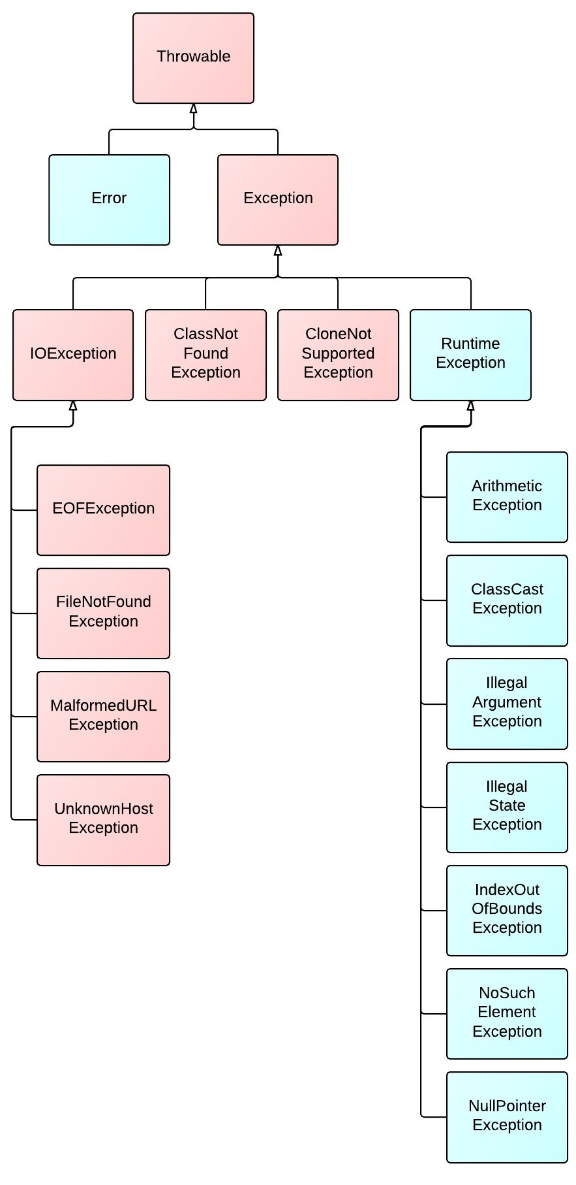

The exception class hierarchy starts with the Throwable class which inherits from Object. Any object which is a Throwable can be "thrown" in a program by the JVM or by the programmer using the throws keyword. The Exception and Error classes both extend Throwable. An Error represents something that went so horribly wrong with your application that you should not attempt to recover from. Some examples of errors are:

* ExceptionInInitializerError
* OutOfMemoryError
* StackOverflowError

Exception is a general exception class which provides an abstraction for all exceptions. There are many subclasses of Exception, as shown above.

## **Unchecked vs Checked Exceptions**

The Exception class and all of its subclasses, except for RuntimeException, are known as "checked exceptions". These represent occasions where it is reasonable to anticipate an unexpected condition, like a file not existing when attempting to write to it (which would result in a FileNotFoundException). **Checked exceptions are required to be handled or declared by the programmer** - otherwise, the code will not compile.

RuntimeException is a special type of exception - it, and all of its subclasses - are known as "unchecked exceptions". An **unchecked exception** is an exception that **is not required to be handled or declared** like checked exceptions are. Some examples include:

* ArithmeticException for illegal math operations
* IndexOutOfBoundsException for if you reference an index that is greater than the length of an array
* NullPointerException for if you attempt to perform an operation on a reference variable that points to a null value

**Try-with-resources**

## **Try-with-resources**

When using try/catch blocks, often times some object used in the code is a resource that should be closed after it is no longer needed to prevent memory leaks - for example a FileReader, InputStream, or a JDBC Connection object. With Java 7, we can use a try-with-resources block which will automatically close the resource for us:

#### **Old way**

**try** {

**InputStream** is = **new** **FileInputStream**("./some/file.ext");

**String** s = is.**read**();

} **catch**(**IOException** e) {

} **finally** {

is.**close**();

}

#### **New way**

**try**(**InputStream** is = **new** **FileInputStream**("./some/file.ext")) {

**String** s = is.**read**();

} **catch**(**IOException** e) {}

Whatever is placed within the parenthesis of the try statement will be closed automatically - thus, we don't need to explicitly call it within our finally block above. This new format requires the object in the try statement to **implement the [AutoCloseable](https://docs.oracle.com/javase/8/docs/api/java/lang/AutoCloseable.html" \t "_blank) interface**.

**Multi-catch blocks**

## **Try/catch/finally Blocks**

In order to handle exceptions that could be thrown in our application, a try/catch block can be used. The try block encloses the code that may throw an exception, and the catch block defines an exception to catch and then runs the code inside only if that type of exception is thrown. We can optionally include a finally block which will run whether an exception is thrown or not. A simple example is shown below:

**try** {

object.**someRiskyMethodCall**();

} **catch**(**Exception** e) {

**System**.out.**println**("phew! that was close!");

} **finally** {

**System**.out.**println**("I'll run whether there was a problem or not!");

}

### Try/catch/finally & Multi-catch Block Rules

Catch and finally blocks have several different rules which must be followed:

* Multiple catch blocks are allowed. More specific exceptions must come before more general exception types.
* Multi-catch blocks (catching more than one exception in a given block) are allowed, exception types are separated by ||
* The finally block is optional
* A try/finally block only IS allowed, but a try block by itself is not
* A finally block will always execute, unless of course System.exit() is called.

## **Custom Exceptions**

A programmer can create custom exceptions in Java by extending any exception class. If you extend RuntimeException, however, you will be creating an unchecked exception. This is a good idea if you do **not** want other code to have to handle your exception being thrown. If you do always want to require your exception to be handled, then create a checked exception by extending any existing one, or the Exception class itself.

**public** **class** **MyCheckedException** **extends** **Exception** {}

**public** **class** **MyUncheckedException** **extends** **RuntimeException** {}

**public** **class** **ExceptionThrower** {

**public** **static** **void** **main**(**String**[] args) {

**try** {

**throw** **new** **MyCheckedException**("uh oh");

} **catch**(**MyCheckedException** e) {} // we're just ignoring it here

**if** ( 100 > 1) {

**throw** **new** **MyUncheckedException**("you're not required to handle me!");

}

}

**public** **static** **void** **declareChecked**() **throws** **MyCheckedException** {

**throw** **new** **MyCheckedException**("this one is declared!");

}

}

**Collection API**

## **Collections Framework**

The Collections framework in Java is a set of classes and interfaces that implement commonly used data structures. A collection is a single object which acts as a container for other objects. The Collections API is organized in a class hierarchy shown in simplified version below:

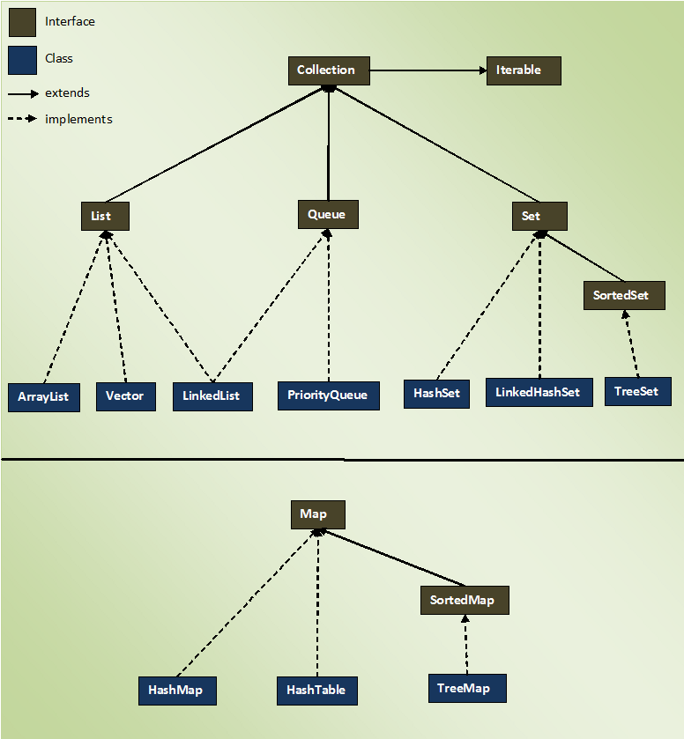

The important interfaces in the Collections API are:

* Iterable - guarantees the collection can be iterated over
* List - an ordered collection
* Set - a collection does not contain duplicates
* Queue - a collection that operates on a first-in-first-out (FIFO) basis
* Map - contains key/value pairs. Does not extend Iterable.

## **Collections Class**

The [Collections](https://docs.oracle.com/javase/8/docs/api/java/util/Collections.html) class - not to be confused with the Collection interface - defines many static helper methods which operate on any given collection. Use this class for help with sorting, searching, reversing, or performing other operations on collections.

**Lists**

## **List Interface**

A List is a collection that is ordered and preserves the order in which elements are inserted into the list. Contrary to sets, duplicate entries are allowed. Also, elements are accessed by their index, which begins with 0 for the first element in the list.

### Vector

Vector is an older class which implements List - it is essentially a thread-safe implementation of an ArrayList.

### Stack

Stack is an older implementation of the stack data structure (last-in-first-out, or LIFO). Generally you should use an ArrayDeque for implementing a stack.

**Sets**

## **Set Interface**

Set is an interface which defines a data structure which:

* is NOT index driven
* only allows unique elements
* generally DOES NOT preserve the order in which elements were inserted

**Queues**

## **Queue Interface**

A Queue is a data structure used when elements should be added and removed in a specific order. Unless specified, elements are ordered FIFO (first-in-first-out). Some useful methods declared are:

* offer()
* peek()
* poll()

**Maps**

## **Map Interface**

Map does not implement the Collection interface, however it is considered to be part of the Collections framework. It is used to identify a value by a key, and each entry in a map is a key-value pair. Because it does not implement Iterable, Maps cannot be iterated over directly. Instead, one must either:

* use the entrySet() method to iterate over the set of Map.Entry
* use the keySet() method to iterate over the set of keys
* use the values() method to return a Collection of values which can then be iterated over

### HashMap

HashMap is a Map which:

* Stores elements in key-value pairs
* Insertion/Retrieval of element by key is fast
* Tradeoff is that it does not maintain the order of insertion
* Permits one null key and null values

### TreeMap

TreeMap is a Map whose:

* Keys are stored in a Sorted Tree structure
* Main benefit is that keys are always in a sorted order
* Insertion/Retrieval are slow
* Cannot contain null keys as null cannot be compared for sorting

### HashTable

HashTable is an older, thread-safe implementation of a HashMap. It does not allow null keys or null values.

**HashSet and TreeSet**

HashSet

A HashSet implements Set and is backed by a HashMap. It:

* Guarantees no ordering when iterating
* Allows one null value
* Allows fast insertion and traversal
* Does not maintain order in which you insert elements

TreeSet

A TreeSet is a Set whose elements maintain sorted order when inserted. Internally, it is backed by a Sorted Tree. Insertion and removal of elements is slow, because the elements must maintain sorted order. It cannot contain any null values, since null cannot be compared to any object.

**ArrayList and LinkedList**

ArrayList

An ArrayList is a concrete class which implements List. It is a data structure which contains an array within it, but can resize dynamically. Once it reaches maximum capacity, an ArrayList will increase its size by 50% by copying its elements to a new (internal) array. Traversal is fast (constant time) because elements can be randomly accessed via index, just like an array. Insertion or removal of elements is slow, however (linear time, since there is a risk of having to resize the underlying array).

LinkedList

A LinkedList implements both the List and Queue interfaces, so it has all methods in both interfaces. The data structure is composed of nodes internally, each with a reference to the previous node and the next node - i.e. a doubly-linked list. Because of this structure, insertion or removal of elements is fast (no risk to resize, just change the nearest references), but traversal is slow for an arbitrary index.

**ArrayDeque and PriorityQueue**

## **ArrayDeque**

Pronounced as 'array-deck', this concrete class can be implemented for either the queue or stack data structure. It is an implementation of a pure double-ended queue (elements can be added or removed from either end of the queue). An ArrayDeque stores elements in a resizable array internally, and it has a few extra useful methods defined:

* pop()
* push()
* peekFirst()
* peekLast()
* pollFirst()
* pollLast()
* offerFirst()
* offerLast()

| **Operation** | **Throws Exception** | **Returns null** |
| --- | --- | --- |
| Insert | boolean add(E e) | boolean offer(E e) |
| Remove | E remove() | E poll() |
| Examine | E element() | E peek() |

## **PriorityQueue**

We know that Queue serves the requests based on FIFO(First in First out) but sometimes the elements of the queue are needed to be processed according to the priority, that’s when the PriorityQueue comes into a picture.

A PriorityQueue serves the requests based on the priority heap. The elements of the priority queue are ordered according to their natural ordering, or by a Comparator provided at queue construction time, depending on which constructor is used. A priority queue does not permit null elements. A priority queue relying on natural ordering also does not permit insertion of non-comparable objects (doing so may result in ClassCastException).

### Methods of PriorityQueue Class

* boolean add(E e) - Inserts the specified element into this priority queue.
* void clear()- Removes all of the elements from this priority queue.
* Comparator<? super E> comparator() - Returns the comparator used to order the elements in this queue, or null if this queue is sorted according to the natural ordering of its elements.
* boolean contains(Object o) -Returns true if this queue contains the specified element.
* Iterator<E> iterator() -Returns an iterator over the elements in this queue.
* boolean offer(E e) -Inserts the specified element into this priority queue.
* E peek() -Retrieves, but does not remove, the head of this queue, or returns null if this queue is empty.
* E poll() -Retrieves and removes the head of this queue, or returns null if this queue is empty.
* boolean remove(Object o) -Removes a single instance of the specified element from this queue, if it is present.
* int size() -Returns the number of elements in this collection.
* Object[] toArray() -Returns an array containing all of the elements in this queue.
* <T> T[] toArray(T[] a) -Returns an array containing all of the elements in this queue; the runtime type of the returned array is that of the specified array.

**Comparable Interface**

## **Comparable Interface**

[Comparable](https://docs.oracle.com/javase/8/docs/api/java/lang/Comparable.html) is an interface which defines the natural ordering for a class. A class must implement Comparable if it is to be sorted by the compareTo() method.

**public** **interface** **Comparable**<T> {

**public** **int** **compareTo**(T o);

}

The compareTo() method returns an int which is:

* Zero, if the two objects are equal
* Negative, if this object is smaller than that
* Positive, if this object is greater than that

**Comparator interface**

## **Comparator Interface**

[Comparator](https://docs.oracle.com/javase/8/docs/api/java/util/Comparator.html) is an interface which allows you to define a total ordering on some collection of objects. A class that is to be sorted by compare() does not have to implement Comparator.

**public** **interface** **Comparator**<T> {

**public** **int** **compare**(T firstObject, T secondObject);

}

**Generics**

## **Generics**

Generics are constructs introduced in Java 5 which enforce compile time safety by allowing you to use parameterized types. They are covered here because the are frequently and heavily used with collections. Generics can be declared on a class (generic types), method parameters (generic methods), or return types.

Before Java 5, you had to write something like this and hope other developers understood to only put Strings inside:

List names = new ArrayList();

names.add("Alice"); // good use

name.add(new Object()); // uh oh - we want to prevent this from happening

With generics, you can restrict a class to only accept objects of a given type and the compiler will prevent you from using any other type:

List<String> names = new ArrayList<>(); // using a List of Strings only

names.add("Alice"); // nice!

names.add(new Object()); // now we get a compilation error to stop this - generics save the day!

### Generic Classes

To make a class (or interface) generic, use the angle brackets when declaring it, and use an arbitrary "generic type" which is determined by the invoking code. The generic type can then be reused throughout the class to enforce type safety.

**public** **class** **MyGenericClass**<T> {

**private** T instance;

// simple generic setter method

**public** **void** **setObject**(T object) {

**this**.instance = object;

}

}

### Naming Convention for Generics

Technically, type parameters can be named anything you want. The convention is to use single, uppercase letters to make it obvious that they are not real class names.

* E => Element
* K => Map Key
* V => Map Value
* N => Number
* T => Generic data type
* S, U, V, and so on => For multiple generic data types

***Day - 4***

**Thread Class**

## **Thread Class**

In Java, [multithreading](https://app.revature.com/) is achieved via the [Thread](https://docs.oracle.com/javase/8/docs/api/java/lang/Thread.html) class and/or the [Runnable](https://docs.oracle.com/javase/8/docs/api/java/lang/Runnable.html) interface.

### Thread methods

A few important methods in the Thread class include:

* getters and setters for id, name, and priority
* interrupt() to explicitly interrupt the thread
* isAlive(), isInterrupted() and isDaemon() to test the state of the thread
* join() to wait for the thread to finish execution
* start() to actually begin thread execution after instantiation

A few important static methods are also defined:

* Thread.currentThread() which returns the thread that is currently executing
* Thread.sleep(long millis) which causes the currently executing thread to temporarily stop for a specified number of milliseconds

### Thread Priorities

Priorities signify which order threads are to be run. The Thread class contains a few static variables for priority:

* MIN\_PRIORITY = 1
* NORM\_PRIORITY = 5, default
* MAX\_PRIORITY = 10

## **Creating Threads using Thread class**

* Create a class that extends Thread
  + implement the run() method
  + instantiate your class
  + call the start() method

**public** **class** **MyThread** **extends** **Thread** {

@Override

**public** **void** **run**() {

**System**.out.**println**("Inside the MyThread class");

}

}

**public** **class** **ThreadDemo** {

**public** **static** **void** **main**(**String**[] args) {

**Thread** myRunnable = **new** **Thread**(**new** **MyRunnable**());

**Thread** myThread = **new** **MyThread**();

myRunnable.**start**();

myThread.**start**();

}

**Runnable Interface**

## **Runnable Interface**

In Java, [multithreading](https://app.revature.com/) is achieved via the [Thread](https://docs.oracle.com/javase/8/docs/api/java/lang/Thread.html) class and/or the [Runnable](https://docs.oracle.com/javase/8/docs/api/java/lang/Runnable.html) interface.

java.lang.Runnable is an interface that is to be implemented by a class whose instances are intended to be executed by a thread.

### Creating Threads using Runnable Interface

* Create a class that implements the Runnable functional interface
  + implement the run() method
  + pass an instance of your class to a Thread constructor
  + call the start() method on the thread

**public** **class** **MyRunnable** **implements** **Runnable** {

@Override

**public** **void** **run**() {

**System**.out.**println**("Inside the MyRunnable class");

}

}

### Runnable and Lambda Expressions

Because Runnable is a functional interface, we can use a lambda expression to define thread behavior inline instead of implementing the interface in a separate class. We pass a lambda expression as the Runnable type required in the Thread constructor. For example:

**public** **class** **ThreadLambda** {

**public** **static** **main**(**String**[] args) {

**Thread** willRun = **new** **Thread(**() -> {

**System**.out.**println**("Running!");

});

willRun.**start**();

}

}

**States of a Thread**

## **States of a Thread**

At any given time, a thread can be in one of these states:

1. **New**: newly created thread that has not started executing
2. **Runnable**: either running or ready for execution but waiting for its resource allocation
3. **Blocked**: waiting to acquire a monitor lock to enter or re-enter a synchronized block/method
4. **Waiting**: waiting for some other thread to perform an action without any time limit
5. **Timed\_Waiting**: waiting for some other thread to perform a specific action for a specified time period
6. **Terminated**: has completed its execution

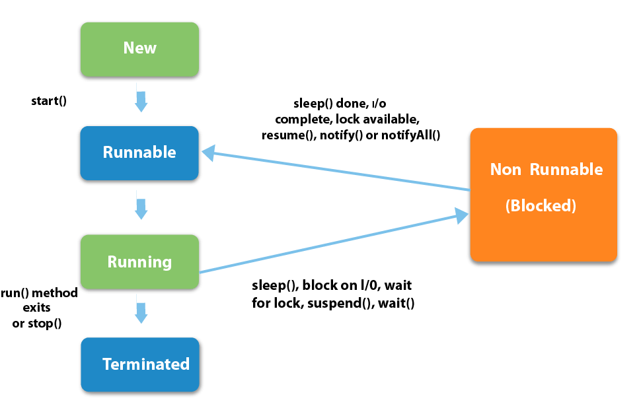

**Multithreading**

# **Intro to Multithreading**

### Concurrency

**Concurrency** refers to breaking up a task or piece of computation into different parts that can be executed independently, out of order, or in partial order without affecting the final outcome. One way - but not the only way - of achieving concurrency is by using multiple threads in the same program.

Operating systems use concurrency to manage the many different programs that run on them. The GUI - graphical user interface - for example, is run at the same time as other processes. Without this, any process that took too long in the background, like reading / writing to files or making an HTTP request, would block the GUI and prevent any other user input.

### Multi-core Processing

Most computers these days have multiple cores or CPUs, which means that calculations at the hardware level can be done in parallel. Without multiple cores, operating systems can still achieve concurrency with a process called **time splicing** - this means running one process for a short time, then switching to another, and back very rapidly. This ensures that no process or application is completely blocked.

On multi-core systems, different processes can be run on different CPUs entirely. This enables true parallelization and is a key benefit of writing multithreaded programs.

### Introduction to Threads

A thread is a subset of a process that is also an independent sequence of execution, but threads of the main process run in the same memory space, managed independently by a scheduler. So, we can think of a thread as a "path of execution", but they can access the same objects in memory.

Every thread that is created in a program is given its own call stack, where it stores local variables references. However, all threads share the same heap, where the objects live in memory. Thus, two threads could have separate variable references on two different stacks that still point to the same object in the heap.

### Multithreading

Multithreading extends the idea of multitasking into applications where you can subdivide operations in a single application into individual, parallel threads. Each thread can have its own task that it performs. The OS divides processing time not just with applications, but between threads. Multi-core processors can actually run multiple different processes and threads concurrently, enabling true parallelization.

In Java, multithreading is achieved via the [Thread](https://docs.oracle.com/javase/8/docs/api/java/lang/Thread.html) class and/or the [Runnable](https://docs.oracle.com/javase/8/docs/api/java/lang/Runnable.html) interface.

#### **A Note on Best Practices**

In general, it is best to avoid implementing multithreading yourself if possible. The benefit of multithreaded applications is better performance due to non-blocking execution. However, you should always measure or attempt to estimate the performance benefit you will get by using threads versus the tradeoff in complexity and subtle bugs that might be generated. Usually there are frameworks, tools, or libraries that have implemented the problem you are trying to solve, and you can leverage those instead of trying to build your own solution. For example, web servers like Apache Tomcat have multithreading built-in and provide APIs for dealing with network requests without having to worry about threads.

**Synchronization**

# **Synchronization**

Synchronization is the capability to control the access of multiple threads to any shared resource.

### Synchronized keyword

In a multithreaded environment, a race condition occurs when 2 or more threads attempt to access the same resource. Using the synchronized keyword on a piece of logic enforces that only one thread can access the resource at any given time. synchronized blocks or methods can be created using the keyword. Also, one way a class can be "thread-safe" is if all of its methods are synchronized.

**synchronized**(objectidentifier) {

// Access shared variables and other shared resources

}

**Producer / Consumer problem**

## **Producer-Consumer Problem**

The Producer-Consumer problem is a classic example of a multi-process synchronization problem. Here, we have a fixed-size buffer and two classes of threads - producers and consumers. Producers produces the data to the queue and Consumers consume the data from the queue. Both producer and consumer shares the same fixed-size buffer as a queue.

**Problem** - The producer should produce data only when the queue is not full. If the queue is full, then the producer shouldn't be allowed to put any data into the queue. The consumer should consume data only when the queue is not empty. If the queue is empty, then the consumer shouldn't be allowed to take any data from the queue.

We can solve the Producer-Consumer problem by using wait() & notify()methods to communicate between producer and consumer threads. The wait() method to pause the producer or consumer thread depending on the queue size. The notify() method sends a notification to the waiting thread.

Producer thread will keep on producing data for Consumer to consume. It will use wait() method when Queue is full and use notify() method to send notification to Consumer thread once data is added to the queue.

**public** **synchronized** **void** **produce**() {

**while** (queue.**size**() == MAX\_SIZE) {

//Queue is full, Producer thread waiting for consumer to take data from the queue

**wait**();

}

/\* When queue has space, Producer produces the data and adds them into the queue.

\* After that, Producer sends the notification to the Consumer.

\*/

//producing data

queue.**add**(data);

**notify**();

}

Consumer thread will consume the data form the queue. It will also use wait() method to wait if queue is empty. It will also use notify() method to send notification to producer thread after consuming data from the queue.

**public** **synchronized** **String** **consume**() {

**while** (messages.**isEmpty**()) {

//Queue is empty, Consumer thread waiting for producer to put data to the queue

**wait**();

}

/\* When queue has data, Consumer consumes the data and removes it from the queue.

\* After that, Consumer sends the notification to the Producer.

\*/

//consuming data

queue.**remove**(data);

**notify**()

}

**Lambdas**

## **Lambda Expressions**

Lambda expressions are one of the biggest new features of Java 8, and they introduce some important aspects of **functional programming** to Java. The most basic syntax of a lambda expression is:

**parameter**(s) -> expression

For example, we can use the .forEach method of the Iterable interface, which accepts a lambda expression as its argument:

**List**<**String**> names = **new** **ArrayList<>**();

names.**add**("Alice");

names.**add**("Bob");

names.**add**("Charlie");

names.**forEach**(str -> **System**.out.**println**(str));

This will print out the names just as if we had used a for loop. The lambda syntax could also be done with an explicit type declaration for the parameter, but the compiler can infer the type from the value used. For multiple parameters, parentheses are required around them. Also, curly braces are optional for single statements but required for multiple. Finally, the return keyword is also optional for a single expression because the value will be returned by default.

**Functional Interfaces**

## **Functional Interfaces**

[Functional interfaces](https://docs.oracle.com/javase/8/docs/api/java/util/function/package-summary.html) are interfaces that **have only one abstract method**. This method is what lambdas are implementing when they are declared - the parameter types and return types of the lambda must match the functional interface method declaration. The Java 8 JDK comes with many built-in functional interfaces, listed in the Javadocs link above.

We can also use functional interfaces as types to which we can assign lambda functions, like so:

**interface** **MyFunctionalInt** {

**int** **doMath**(**int** number);

}

**public** **class** **Execute** {

**public** **static** **void** **main**(**String**[] args) {

**MyFunctionalInt** doubleIt = n -> n \* 2;

**MyFunctionalInt** subtractIt = n -> n - 2;

**int** result1 = doubleIt.**doMath**(2);

**int** result2 = subtractIt.**doMath**(8);

**System**.out.**println**(result1); // 4

**System**.out.**println**(result2); // 6

}

}

**Stream API**

## **Stream API**

The Java 8 [Stream API](https://docs.oracle.com/javase/8/docs/api/java/util/stream/package-summary.html) is a functional-style way of defining operations on a stream of elements. Streams are an abstraction which allow defining operations which do not modify the source data and are lazily executed. Streams **do not store data**, they simply define operations like filtering, mapping, or reducing, and can be combined with other operations and then executed. Some built-in Streams are located in the java.util.stream package.

Streams are divided into intermediate and terminal operations. Intermediate streams return a new stream and are always lazy - they don't actually execute until a terminal operation is called. Terminal operations trigger the execution of the stream pipeline, which allows efficiency by perfoming all operations in a single pass over the data.

Finally, reduction operations take a sequence of elements and combine them into a single result. Stream classes have the reduce() and collect() methods for this purpose, with many built-in operations defined in the Collectors class.

**List**<**Student**> students = **new** **ArrayList<>**();

// add students...

**List**<**Double**> grades = students.**stream**()

.**filter**(s -> s.**isAttending**())

.**mapToDouble**(s -> s.getGrade)

.**collect**(**Collectors**.**toList**());

**Serialization**

## **Serialization**

Serialization is the process of writing the state of an object to a byte stream; the reverse is called deserialization. In order for an object to be serialized, it must implement the Serializable interface.

### Marker Interfaces

Serializable is a **marker interface**, which is an interface with no methods. The point of such an interface is to provide metadata to the compiler - in this case, it tells the compiler that this class can be serialized.

### Serializing an object

To serialize an Object, you need a FileOutputStream instance inside the constructor of an ObjectOutputStream, passing in the file path of where you want the Object to be serialized

* Call the ObjectOutputStream.writeObject(yourObject) method

### Deserializing an object

To deserialize an Object, you need a FileInputStream instance inside the constructor of an ObjectInputStream, passing in the file path of where the serialized object is

* Call the ObjectInputStream.readObject() method, casting it to a bean of your type

**File I/O: FileInputStream/FileReader/FileWriter**

## **File I/O**

"I/O" refers to the nature of how data is accessed, either by reading it from a resource (input) or writing it to a resource (output). In Java, File I/O objects fall into one of two categories:

* Streams are for reading or writing **bytes**
* Reader/Writer are for reading or writing **characters**

Some Common File I/O classes are

* FileInputStream - reads raw bytes from a file
* FileOutputStream - writes raw bytes to a file
* FileReader - reads characters from a file
* FileWriter - writes characters to a file
* BufferedReader - reads a file line by line, needs an instance of a FileReader with a path to the resource to be read in the constructor
* BufferedWriter - writes to a file line by line, needs an instance of a FileWriter with a path to the destination file in the constructor
* Scanner - can read from an InputStream, useful methods for character reading

Character files are read line by line, either until a carriage return (\r) or a newline (\n), depending on your operating system. When using I/O classes to read and write, you should **always close your resources** with the .close() method. This prevents exceptions from being thrown later, memory leaks, and system overutilization of unused resources.

**Read from console (Scanner)**

## **Reading User Input from Console**

The Scanner class can be used to read user input from the command line:

**Scanner** sc = **new** **Scanner**(**System**.in);

**while** (true) {

**String** input = sc.**readLine**();

**System**.out.**println**("Your input: " + input);

}

When the code above is run, the program acts to "echo" back any input given from stdin.

***DAY \_-5***

**Creational: Singleton**

## **Singleton Pattern**

A Singleton is a design pattern which allows the creation of an object in memory only once in an application and can be shared across multiple classes. It can be useful for services in an application, or other resources like a connection or thread pool.

There are many benefits to using a Singleton:

1. There will only be 1 instance, which allows coordination across a system.
2. There is a clear way to fetch the correct instance. getInstance()
3. Programmer has complete control over instantiation.
4. global access point
5. The singleton is not created until it is used, often referred to as lazy instantiation.

There are also many drawbacks to using a Singleton:

1. Harder to work with in multithreading.
2. Different components can be given too much control over other components.

To make a class into a Singleton, use:

1. private static variable of the class' type
2. private constructor - to prevent arbitrary object creation
3. public static getInstance() method, which will either instantiate the object or return the instance in memory

**public** **class** **Singleton** {

// Private static variable of the class' type

**private** **static** **Singleton** instance;

**private** **int** number;

// Private Constructor

**private** **Singleton**() {

number = 0;

}

// Public static getInstance method

**public** **static** **Singleton** **getInstance**() {

**if** (instance == null)

instance = **new** **Singleton**();

**return** instance;

}

//this method is called from an instance of the class.

//However because there is only 1 instance, whenever this is called it will affect all pointers to the instance.

**public** **void** **printer**(){

**this**.number++;

system.out.**println**("printer has been called " + **this**.number + " times.");

}

}

**class** **Main**{

**public** **static** **void** **main**(**String**[] args){

**Singleton** mySingle = **Singleton**.**getInstance**(); //When this is called the first time the singleton does not exist, so it gets created.

mySingle.**printer**(); // output: printer has been called 1 times

**Singleton** yourSingle = **Singleton**.**getInstance**(); //This time when getInstance is called there already exists an instance, so it just returns the reference to the singleton.

yourSingle.**printer**(); // output: printer has been called 2 times

**System**.out.**println**(mySingle == yourSingle); //This will output true, because mySingle points to the same object as yourSingle

}

}

There are many situations to use a Singleton:

1. many other creational patterns need to limit the number of objects.
2. Facade (another common design pattern) objects are often singletons.
3. State objects may break if there are duplicates.
4. Objects used by many different pieces, such as game boards or memory.
5. And many more.

**Creational: Factory**

## **Factory Pattern**

Factory is a design pattern which creates objects in which the precise type may not be known until runtime. There are several reasons to use the factory pattern:

1. If you don't know the exact types needed before running the code.
2. If you want to hide the creational logic, which prevents end user creating things that they shouldn't.
3. If you need an easy way to extend internal components.
4. Depending on implementation, the factory pattern can be used to reuse objects, instead of making new ones, which saves space.

Some extra benefits of using the factory pattern:

1. Single responsibility is upheld by putting all of the construction code in a single function.
2. Open/Closed principle is upheld by allowing new subclasses to easily implement and be added, without negatively affecting any of the already written classes.
3. Abstracts the actual creation of the objects away from the user.

To make a factory, use:

1. Create the abstract data type
2. Create several classes that inherit the abstract data type (the objects whose instantiation details may not be known until runtime)
3. Set up a static method whose return type is the abstract data type in (1), which will return the concrete instance

// Abstract Data Type

**public** **interface** **Dessert** {}

// Classes that inherit the abstract data type

**public** **class** **Cake** **implements** **Dessert** {}

**public** **class** **Cookie** **implements** **Dessert** {}

**public** **class** **IceCream** **implements** **Dessert** {}

// Good practice to throw an exception if the desired concrete instance is not found

**public** **class** **DessertNotFoundException** **extends** **RuntimeException** {}

// Factory class that returns the concrete instance

**public** **class** **DessertFactory** {

**public** **static** **Dessert** **getDessert**(**String** dessertType) {

**switch**(dessertType) {

**case** "cake":

**return** **new** **Cake**();

**case** "cookie":

**return** **new** **Cookie**();

**case** "ice cream":

**return** **new** **IceCream**();

**default**:

**throw** **new** **DessertNotFoundException**(dessertType + " not found!");

}

}

**public** **class** **Demo** {

**public** **static** **void** **main**(**String**[] args) {

**Dessert** d1 = **DessertFactory**.**getDessert**("cake");

**Dessert** d2 = **DessertFactory**.**getDessert**("cookie");

**Dessert** d3 = **DessertFactory**.**getDessert**("ice cream");

**Dessert** d4 = **DessertFactory**.**getDessert**("candy"); // Throws DessertNotFoundException

}

}

}

**Introduction to Maven**

## **Introduction to Maven**

[Maven](https://maven.apache.org/index.html) is a tool that can be used for building and managing any Java-based project.

Maven helps in the following ways:

* Simplifies the build process
* Adding jars and dependencies
* Documenting project information with change logs and reports
* Integration with source control systems (Git)

Features of Maven that we will go over:

* Project Object Model (POM)
* Maven lifecycles
* Maven repositories
* Maven project coordinates

**Project object model (POM)**

# **POM - Project Object Model**

[Maven](https://maven.apache.org/) is a dependency manager and build automation tool for Java programs. Maven project configuration and dependencies are handled via the Project Object Model, defined in the pom.xml file. This file contains information about the project used to build the project, including project dependencies and plugins.

Some other important tags within the pom.xml file include:

* <project> - this is the root tag of the file
* <modelVersion> - defining which version of the page object model to be used
* <name> - name of the project
* <properties> - project-specific settings
* <dependencies> - this is where you put your Java dependencies you want to use. Each one needs a <dependency>, which has:
  + <groupId> , <artifactId>, <version> - [project coordinates](https://app.revature.com/)
* <plugins> - for 3rd party plugins that work with Maven

Here's an example:

<project>

<modelVersion>4.0.0</modelVersion>

<groupId>com.revature.app</groupId>

<artifactId>my-app</artifactId>

<version>1</version>

<dependencies>

<dependency>

<groupId>org.apache.maven</groupId>

<artifactId>maven-artifact</artifactId>

<version>${mavenVersion}</version>

</dependency>

<dependency>

<groupId>org.apache.maven</groupId>

<artifactId>maven-core</artifactId>

<version>${mavenVersion}</version>

</dependency>

</dependencies>

</project>

**Maven Lifecycles**

## **Maven Build Lifecycle**

When Maven builds your project, it goes through several steps called **phases**. The default maven build lifecycle goes through the following phases:

1. Validate => project is correct and all necessary information is available
2. Compile => compiles project source code
3. Test => tests all compiled code
4. Package => packages all compiled code to WAR/JAR file
5. Integration => performs all integration tests on WAR/JAR
6. Verify => runs checks on the results of integration tests
7. Install => installs WAR/JAR to local repository
8. Deploy => copies final WAR/JAR to the remote repository

Each phase in turn is composed of plugin goals that are bound to zero or more build phases. A "goal" represents a specific task which contributes to the building or managing of the project.

For more information, see the [Maven documentation](https://maven.apache.org/guides/introduction/introduction-to-the-lifecycle.html).

## **Using the mvn command**

To use the Maven CLI (command-line interface), first test that you have Maven installed:

mvn --version

Now, once you are in your project directory, you can run any phase in the default build lifecycle. Maven will look for the pom.xml file and use that to run the phase.

cd /path/to/myproject/

mvn package

To execute a specific Maven goal, use the plugin:goal syntax:

mvn dependency:copy-dependencies

Multiple phases or goals can be run sequentially. Again, see the Maven documentation for more information.

\

**Maven Repositories**

## **Maven Repositories**

When Maven "builds" a Java project, it must first search for any dependencies declared in the pom.xml file. Maven dependencies are stored both locally and in a central repository. The local repository is in the $HOME/.m2/repository folder (can be changed in $MAVEN\_HOME/conf/settings.xml), while the central repository is accessible at [https://mvnrepository.com](https://mvnrepository.com/). If Maven cannot find a given dependency locally, it searches the central repository for the artifact and then downloads it to the local repository.

A Maven "build" means to take the project source code, along with any dependencies like libraries or frameworks, compile it, and bundle it all together into an artifact - this could be a .war file, a .jar file, or an .ear file. WAR stands for "web archive", JAR stands for "Java archive", and EAR stands for "Enterprise Application archive". This artifact can then be either directly run or deployed onto a web container (in the case of a web application).

**Project Coordinates**

## **Maven Project Coordinates**

Maven Project coordinates identify uniquely a project, a dependency, or a plugins defined in the pom.xml file - these are:

* group-id - The group, company, team, organization, project, or other group. for example: "com.revature"
* artifact-id - A unique identifier under groupId that represents a single project. for example: "myproject"
* version - A specific release of a project. Projects that have been released have a fixed version identifier that refers to a specific version of the project. Projects undergoing active development can use a special identifier that marks a version as a SNAPSHOT. for example: "0.0.1-SNAPSHOT"
* packaging- The type of project, defaulting to jar, describing the packaged output produced by a project. A project with packaging jar produces a JAR archive; a project with packaging war produces a web application.

**Overview of Logging**

## **Log4j**

Log4j is a reliable, fast, and flexible logging framework for Java supported by Apache. It's commonly used to record application events, log granular debugging information for developers, and write exception events to files.

## **Why do we need logging?**

Logging records events that occur during software execution. As users execute programs on the client side, the system accumulates log entries for support teams. In general, it allows for developers to access information about applications to which we do not have direct access. Without logs, we would have no idea of knowing what went wrong when an application crashes, or track and monitor application performance.

Also, a logging framework like Log4j is critical because it allows us to use various logging levels and configure a threshold to determine which messages will be recorded in the application log files.

**Logging Levels**

## **Log4j Usage**

Log4j has a simple class architecture as shown below:

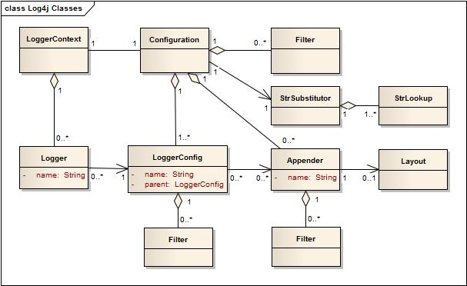

The main components of the hierarchy are:

* Logger - logs the messages
* Appender - publishes logs to destination(s)
* Layout - formats logging information
* Configuration - stores settings
* Filter - used to filter out logs that do not meet the threshold

### Log4j Logging Levels

Below are the Log4j log levels, in order of least to most restrictive:

1. **ALL** => all levels
2. **DEBUG** => designates fine-grained informational events that are most useful to debug an application
3. **INFO** => informational messages that highlight the progress of the application at the coarse grained level
4. **WARN** => designates potentially harmful situations
5. **ERROR** => designates error events that might still allow the application to continue running
6. **FATAL** => severe error events that presumably lead the application to abort
7. **OFF** => highest possible level, intended to turn off logging

### How do logging levels work?

A log request of level x in a logger with level y is enabled with x >= y. For the standard levels, we have that ALL < DEBUG < INFO < WARN < ERROR < FATAL < OFF

### Configuration

Log4j (specifically Log4j2) can be configured using XML, JSON, YML, or Properties files, as described in [their documentation](https://logging.apache.org/log4j/2.x/manual/configuration.html).

### Simple Example

To use Log4j2, first include the library as a dependency. If you're using Maven, simply add the following to your pom.xml file:

<!-- https://mvnrepository.com/artifact/org.apache.logging.log4j/log4j-core -->

<dependency>

<groupId>org.apache.logging.log4j</groupId>

<artifactId>log4j-core</artifactId>

<version>2.11.2</version>

</dependency>

Assuming you've setup some configuration file, you can go ahead and use loggers in your code:

**public** **class** **Foo** {

**private** **static** **Logger** log = **LogManager**.**getLogger**(**Foo**.**class**);

**public** **static** **void** **main**(**String**[] args) {

log.**info**("Hello world!");

log.**warn**("Uh oh");

log.**error**("This is not good!");

}

}

**Setting Logging Threshold**

# **Setting Logging Thershold**

A logger can be assigned a threshold level. All logging requests with level lower than this threshold will be ignored.

For example, setting logger threshold to INFO means that logging requests with levels TRACE and DEBUG will not be logged by this logger.

An example of setting the root logger threshold to INFO:

<configuration xmlns="http://logging.apache.org/log4php/">

<appender name="default" class="LoggerAppenderConsole" />

<root>

<level value="info" />

<appender\_ref ref="default" />

</root>

</configuration>

If not explicitly configured, loggers will have their threshold level set to DEBUG by default.

Class vs Object

Pillars of OOPS

Stack and Heap

Garbage Collections

Control Flow Statements

Packages and Imports

Constructors

Method and parameters

Variable Scopes

Access Modifiers

Introduction to GIT

Day -2

String API

String Builder, String Buffer

Arrays, Var-args, for-each loops

Annotations

Casting

Wrapper Classes

Object Class

Abstract Classes

Interfaces

Intro to TDD and unit Testing

Junit Annotations

Assert methods

Day 3

Exception Handeling or Declarations

WEEK 2

DAY 6

**AWS Introduction**

## **AWS Overview**

### What is Cloud Computing?

Cloud computing is the on-demand delivery of compute power, database storage, applications and other IT resources through a cloud services platform via the Internet with pay-as-you-go pricing.

Cloud computing provides a simple way to access servers, storage, databases and a broad set of application services over the Internet.

### 6 Advantages of Cloud Computing

1. Trade capital expense for variable expense.
2. Benefit from massive economies of scale.
3. Stop guessing about capacity.
4. Increase speed and agility.
5. Eliminate overhead cost of maintaining data centers
6. Go global in minutes.

#### **Trade capital expense for variable expense**

Instead of having to invest heavily in data centers and servers before you know how you’re going to use them, you can pay only when you consume computing resources, and pay only for how much you consume.

#### **Benefit from massive economies of scale**

By using cloud computing, you can achieve a lower variable cost than you can get on your own. Because usage from hundreds of thousands of customers is aggregated in the cloud, providers such as AWS can achieve higher economies of scale, which translates into lower pay as-you-go price.

#### **Stop guessing about capacity**

Eliminate guessing on your infrastructure capacity needs. When you make a capacity decision prior to deploying an application, you often end up either sitting on expensive idle resources or dealing with limited capacity.

#### **Increase speed and agility**

In a cloud computing environment, new IT resources are only a click away, which means that you reduce the time to make those resources available to your developers from weeks to just minutes.

#### **Eliminate overhead cost of maintaining data centers**

Cloud computing lets you focus on your own customers, rather than on the heavy lifting of racking, stacking, and powering servers (infrastructure).

#### **Go global in minutes**

Easily deploy your application in multiple regions around the world with just a few clicks. This means you can provide lower latency and a better experience for your customers at minimal cost.

### Paying for Cloud Services

AWS offers you a **pay-as-you-go** approach for pricing for over 160 cloud services. With AWS you pay only for the individual services you need, for as long as you use them, and without requiring long-term contracts or complex licensing.

* You can also use [AWS Billing and Cost Management](https://docs.aws.amazon.com/awsaccountbilling/latest/aboutv2/billing-what-is.html)

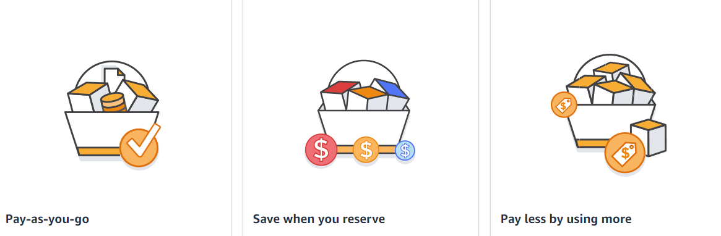

### 3 Models of Cloud Computing

#### **Infrastructure as a Service (IaaS)**

Infrastructure as a Service (IaaS) is a self-service model for managing remote data center infrastructures. AWS offers IaaS in the form of data centers.

#### **Platform as a Service (PaaS)**

Platform as a Service (PaaS) allows organizations to build, run and manage applications without the IT infrastructure. This makes it easier and faster to develop, test and deploy applications.

#### **Software as a Service (SaaS)**

Software as a service (SaaS) replaces the traditional on-device software with software that is licensed on a subscription basis. It is centrally hosted in the cloud. A good example is Salesforce.com.

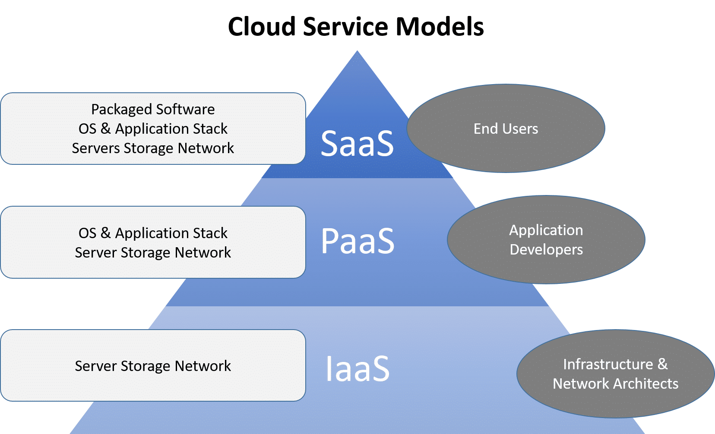

### Other Major Cloud Providers

* [Microsoft Azure](https://azure.microsoft.com/en-us/)
* [Google Cloud Platform (GCP)](https://cloud.google.com/gcp/?utm_source=google&utm_medium=cpc&utm_campaign=na-US-all-en-dr-bkws-all-all-trial-e-dr-1009135&utm_content=text-ad-lpsitelinkCCexp2-any-DEV_c-CRE_113120492887-ADGP_Hybrid+%7C+AW+SEM+%7C+BKWS+%7C+US+%7C+en+%7C+EXA+~+Google+Cloud+Platform-KWID_43700009942847400-kwd-26415313501&utm_term=KW_google%20cloud%20platform-ST_google+cloud+platform&&gclid=Cj0KCQjwoJX8BRCZARIsAEWBFMIKqoP4b6G-3OlpQkCrVvMoAvss3kNL_2joyIs7N42TL-2WZRBCUaoaApspEALw_wcB)

**AWS RDS**

# **RDS Overview**

The following overview will cover:

* What is Amazon RDS?
* Why use RDS?
* Regions & Availability Zones
* Security
* How to interact with Amazon RDS
* Using AWS RDS vs. Installing a database on an AWS EC2 Instance

## **What Is Amazon Relational Database Service (Amazon RDS)?**

Amazon Relational Database Service (Amazon RDS) is a web service that makes it easier to set up, operate, and scale a relational database in the AWS Cloud. It provides cost-efficient, resizable capacity for an industry-standard relational database and manages common database administration tasks.  
  


* RDS **automates** expensive and time consuming tasks such as managing backups, software patching, automatic failure detection, and recovery.
* You can help control who can access your RDS databases by using **AWS Identity and Access Management (IAM)** to define users and permissions.
* RDS is available on several **database instance types**. **Instance types** comprise varying combinations of CPU, memory, storage, and networking capacity and give you the flexibility to choose the appropriate mix of resources for your database.
  + Examples of instance types include T3, T2, M6g, M5, etc...You can read more about instance types [here](https://aws.amazon.com/rds/instance-types/).

* RDS is **free to try** and you will be charged based on how much computational power you use per month (pay-as-you-go).
* RDS provides you with six familiar database engines to choose from, including Amazon Aurora, PostgreSQL, MySQL, MariaDB, Oracle Database, and SQL Server.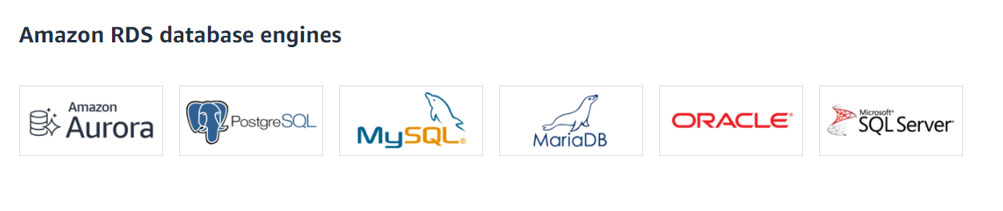

## **Why Use RDS?**

It's important to distinguish AWS RDS from other database solutions offered through AWS.

* AWS offers 15 database engines including relational, key-value, document, in-memory, graph, time series, and ledger databases.
* With **RDS**, you don’t need to worry about database management tasks such as server provisioning, patching, setup, configuration, backups, or recovery. The RDS manages this for you.
* **RDS** is a **relational** database service, therefore it organizes data within tables in rows and columns. Compare this to non-relational or NoSQL databases which use different mechanisms to store and retrieve data through key-value pairs, document models, etc.

See the image below to see how AWS RDS differs from other databases available in AWS.

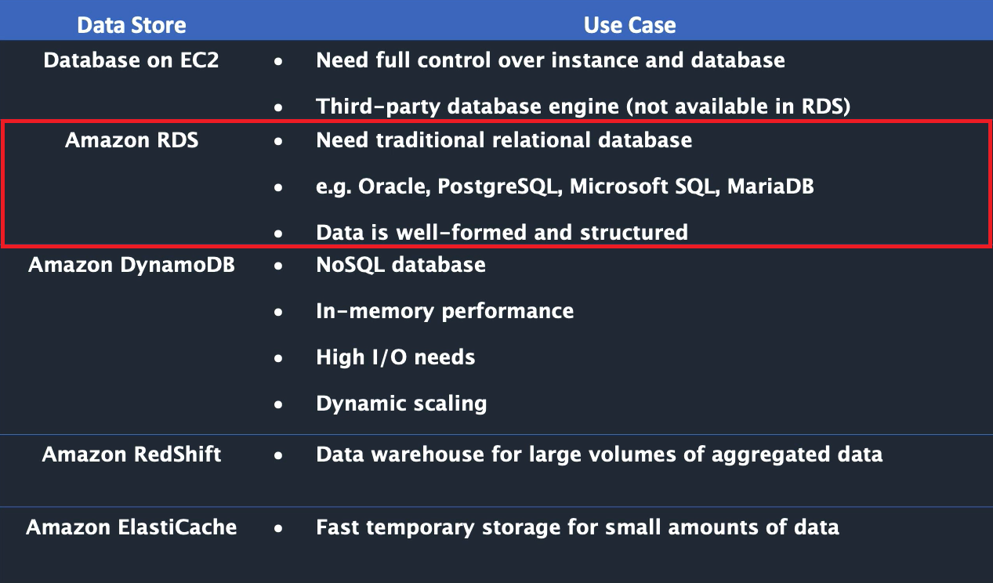

## **Regions & Availability Zones**

* An **AWS Region** is a highly available data center that houses Amazon cloud computing resources in different areas of the world (for example, North America, Europe, or Asia).
* Each AWS Region contains multiple distinct locations called **Availability Zones**, or AZs.
* Each Availability Zone is engineered to be isolated from failures in other Availability Zones. Each is engineered to provide inexpensive, low-latency network connectivity to other Availability Zones in the same AWS Region.
* By launching instances in separate Availability Zones, you can protect your applications from the failure of a single location. This makes AWS fault-tolerant.
  + **Fault-tolerance** defines the ability for a system to remain in operation even if some of the components used to build the system fail.

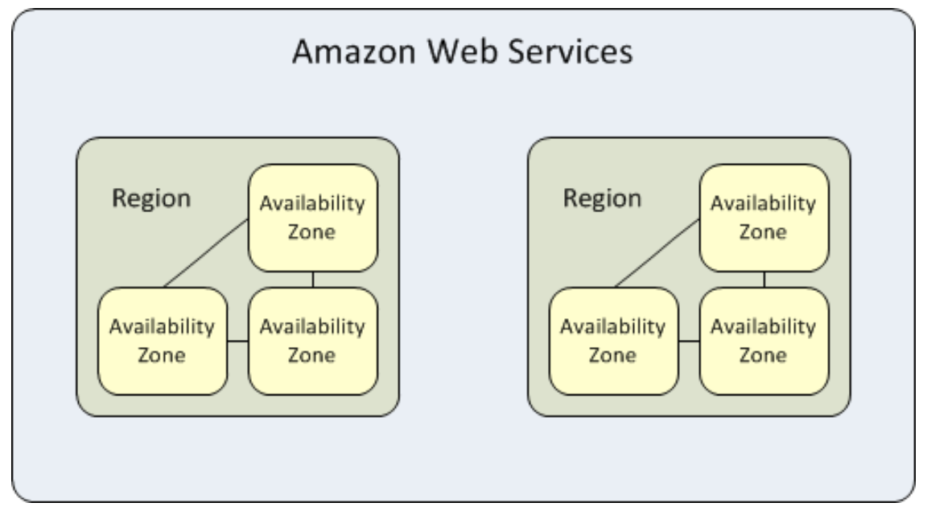

## **Security**

* A **security group** controls the access to a DB instance. It does so by allowing access to IP address ranges or Amazon EC2 instances that you specify.
* You can set security groups when configuring your RDS instance.

## **How to Interact with Amazon RDS**

There are several ways that you can interact with Amazon RDS.

##### **1. AWS Management Console**

You can manage your DB instances from the console with no programming required. To access the Amazon RDS console, sign in to the AWS Management Console and open the Amazon RDS console at <https://console.aws.amazon.com/rds/>

##### **2. Command Line Interface**

You can use the AWS Command Line Interface (AWS CLI) to access the Amazon RDS API interactively. Install the AWS CLI [here](https://docs.aws.amazon.com/cli/latest/userguide/cli-chap-install.html). To begin using the AWS CLI with RDS, view the [AWS CLI Command Reference](https://docs.aws.amazon.com/cli/latest/reference/rds/index.html).

##### **3. Programatically Accessing Amazon RDS**

While developing an application, developers may use the AWS Software Development Kits (SDKs) and utilize the [RDS Application Programming Interface (API)](https://docs.aws.amazon.com/AmazonRDS/latest/UserGuide/ProgrammingGuide.html) to automate tasks for managing DB instances and other objects in Amazon RDS.

## **Using AWS RDS vs. Installing a database on an AWS EC2 Instance**

DB services (like RDS) are managed services, meaning that you have limited control over the actual database. (i.e you can't install particular software you may need).

* **EC2 (Elastic Cloud Compute)**, on the otherhand, gives you maximum control over the software stack, database, and operating system.
* **EC2** allows you compute capacity and SUPER priveleges, increasing flexibility.
* **RDS** is more cost-effective and is automated, but limits your control over the database.
* **RDS** takes care of your database from end-to-end by managing, maintaining, and securing it, eliminating overhead costs and the role of a DBA (Database Administrator).

For a full comparison of AWS RDS vs. EC2 see [this article](https://medium.com/awesome-cloud/aws-amazon-rds-vs-amazon-ec2-relational-databases-comparison-b28eb0802355#:~:text=Whereas%2C%20for%20more%20control%20and,from%20end%2Dto%2Dend.&text=maintaining%2C%20and%20securing.-,Whereas%2C%20for%20more%20control%20and%20flexibility%2C%20EC2%20will%20be,better%20for%20your%20relational%20database.).  
Find the EC2 overview module [here](https://gitlab.com/revature_training/aws-core-team/-/tree/master/modules/ec2).

### References

* [Databases on AWS](https://aws.amazon.com/products/databases/?nc=sn&loc=0)
* [RDS Instance Types](https://aws.amazon.com/rds/instance-types/)

## **AWS Elastic Compute Cloud (EC2)**

Amazon Elastic Compute Cloud (Amazon EC2) is a web service that provides secure, resizable compute capacity in the cloud. It is designed to make web-scale cloud computing easier for developers.

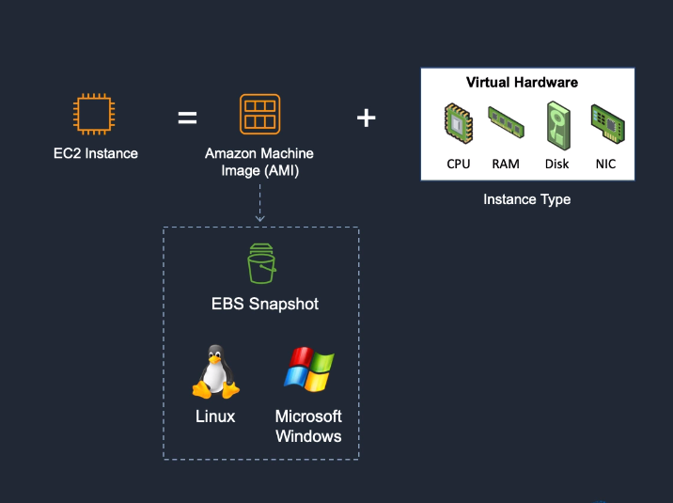

##### **Amazon EC2 provides:**

* Virtual computing environments, known as instances
* Preconfigured templates for your instances, known as **Amazon Machine Images (AMIs)**, that package the bits you need for your server (including the operating system and additional software)
* Various configurations of CPU, memory, storage, and networking capacity for your instances, known as **instance types**
* Secure login information for your instances using key pairs (AWS stores the public key, and you store the private key in a secure place)
* A firewall that enables you to specify the protocols, ports, and source IP ranges that can reach your instances using **security groups**

### Elastic Web-Scale Computing

You can increase or decrease capacity within minutes and commission one to thousands of instances simultaneously.

### Completely Controlled

AWS EC2 give you complete control including root accessto each instance and can stop and start instances without losing data and use web service APIs.

### Flexible Cloud Hosting Serices

You can choose from multiple instance types & operating systems as well as instances with varying memory, CPU, and storage configurations.

#### **Elasticity**

The “Elastic” nature of the service allows developers to instantly scale to meet spikes in traffic or demand. When computing requirements unexpectedly change (up or down), Amazon EC2 can instantly respond, meaning that developers have the ability to control how many resources are in use at any given point in time.

#### **Instances**

An instance is a virtual server in the cloud. Its configuration at launch is a copy of the AMI that you specified when you launched the instance.

You can launch different types of instances from a single AMI. An instance type essentially determines the hardware of the host computer used for your instance. Each instance type offers different compute and memory capabilities. Select an instance type based on the amount of memory and computing power that you need for the application or software that you plan to run on the instance. For more information about the hardware specifications for each Amazon EC2 instance type, see [Amazon EC2 Instance Types](https://aws.amazon.com/ec2/instance-types/).

### Create an EC2 Instance

1. Sign into AWS as a root user. Go to **EC2 Dashboard**. Select Launch Instance.
2. Choose an **Amazon Machin Image (AMI)** - select Amazon Linux 2 AMI (HVM), SSD Volume Type - 64 bit (x86).
3. Choose an **Instance Type** - select t2 micro (Free tier eligible)
4. Skip through steps 3-5 until you get to 6. Configure Security Group.
5. **Configure Security Group**: configure your security group so that you can access your EC2 instance from SSH - change Source to Anywhere.
6. Proceed to launch until you are prompted to Select an existing key pair or create a new key pair.
7. Name your key pair mynewkeypair. Click Download, then click Launch Instance.
8. Your EC2 Instance has now been launched. Go to the [SSH Into EC2 Instance](https://app.revature.com/) to learn how to connect to your EC2 through SSH client.

### References

* [AWS EC2 Documentation](https://docs.aws.amazon.com/AWSEC2/latest/UserGuide/concepts.html)

**SSH Into EC2 Instance**

## **How to SSH into an EC2**

Your EC2 instance will be running in a public subnet. Your EC2 instance has a public address on the internet which you are able to access from wherever you have internet access.

The relevant protocol by which we are able to access the instance is by using **Secure Shell (SSH)** which is the **TCP protocol port 22**.

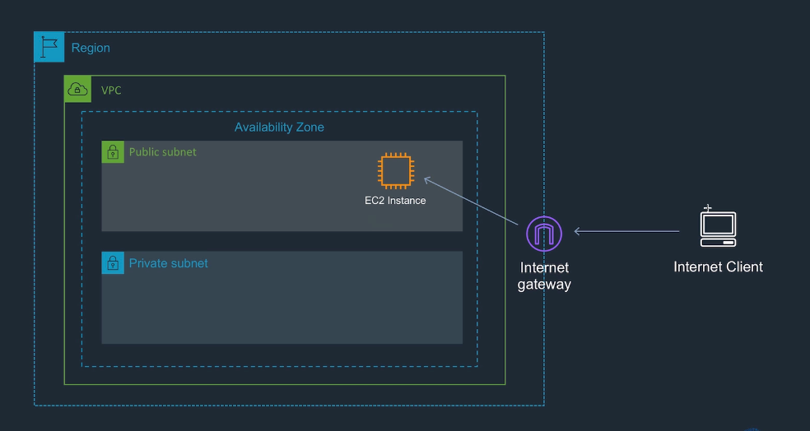

1. On your AWS Management Console, go to EC2 > Instances > and click on the instance that you've just configured. Click Connect > SSH Client.
2. Open Command Prompt on Windows/Linux or Terminal on Mac.
3. Run the command given as Example under the connection instructions:

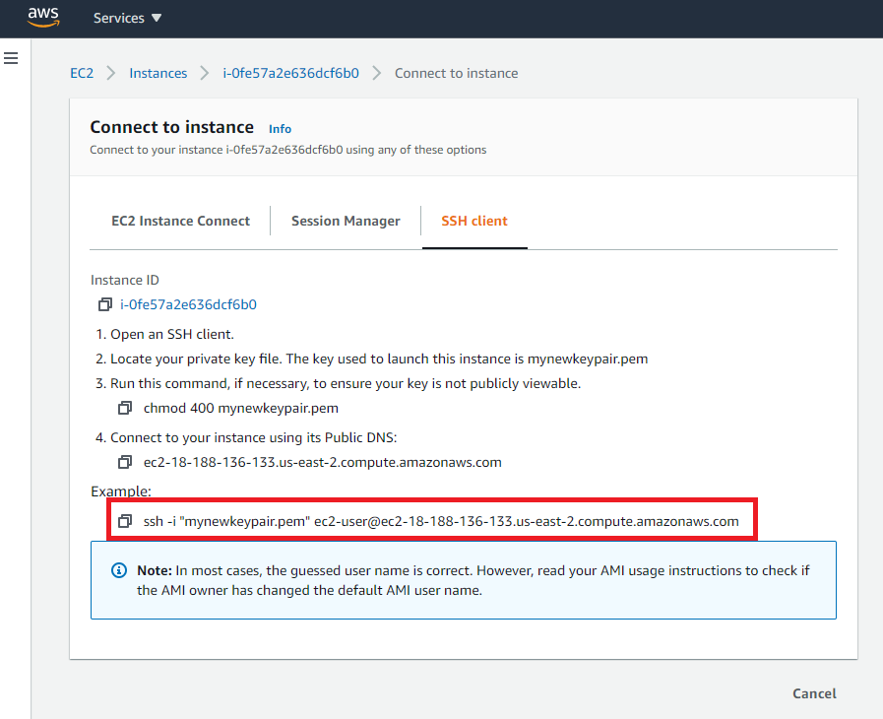

1. You may see the following message

The authenticity of host 'ec2-18-188-136-133.us-east-2.compute.amazonaws.com (18.188.136.133)' can't be established. ECDSA key fingerprint is SHA256:9Je3cWvvII8iQDuranju1h1lqJ+5+8cgThuDgzCzmns. Are you sure you want to continue connecting (yes/no)?

...run yes.

You are now connected from your internet client to your EC2 instance!

### References

* [AWS Guide to Connecting to EC2 Instance via SSH](https://docs.aws.amazon.com/AWSEC2/latest/UserGuide/AccessingInstancesLinux.html)

**Security Groups**

## **Security Groups**

A **security group** acts as a virtual firewall for your EC2 instances to control incoming and outgoing traffic based on their IP address.

* Security group rules enable you to filter traffic based on protocols and port numbers.
* Security groups are stateful — if you send a request from your instance, the response traffic for that request is allowed to flow in regardless of inbound security group rules. Responses to allowed inbound traffic are allowed to flow out, regardless of outbound rules.
* You can add rules to each security group that allow traffic to or from its associated instances. You can modify the rules for a security group at any time.

When demoing configuring an EC2 instance, you should set the security groups before you launch your instance. You can set your first Security Group to *Anywhere*, so that it is easiest to connect from any IP address.

### Changing an instance's security groups

After you launch an instance into a VPC, you can change the security groups that are associated with the instance. You can change the security groups for an instance when the instance is in the running or stopped state.

#### **To change the security groups for an instance using the console**

1. Open the Amazon EC2 console at <https://console.aws.amazon.com/ec2/>.
2. In the navigation pane, choose Instances.
3. Open the context (right-click) menu for the instance and choose Networking > Change Security Groups.
4. In the Change Security Groups dialog box, select one or more security groups from the list and choose Assign Security Groups.

**AMI**

## **Amazon Machine Image (AMI)**

An Amazon Machine Image (AMI) provides the information required to launch an instance. Think of it as a template for an EC2 Instance.

#### **An AMI includes the following:**

* One or more EBS snapshots.
* Launch permissions that control which AWS accounts can use the AMI to launch instances.
* A block device mapping that specifies the volumes to attach to the instance when it's launched.

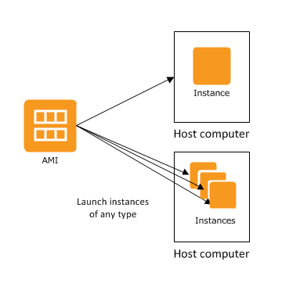

### References

* [AMI Types](https://docs.aws.amazon.com/AWSEC2/latest/UserGuide/ComponentsAMIs.html)

**EBS**

## **Amazon Elastic Block Store (Amazon EBS)**

Amazon Elastic Block Store (Amazon EBS) provides block level storage volumes for use with EC2 instances.

* EBS volumes behave like raw, unformatted block devices. You can mount these volumes as devices on your instances.
* EBS volumes that are attached to an instance are exposed as storage volumes that persist independently from the life of the instance.
* You can create a file system on top of these volumes, or use them in any way you would use a block device (such as a hard drive).
* You can dynamically change the configuration of a volume attached to an instance.
* With Amazon EBS, you pay only for what you use.

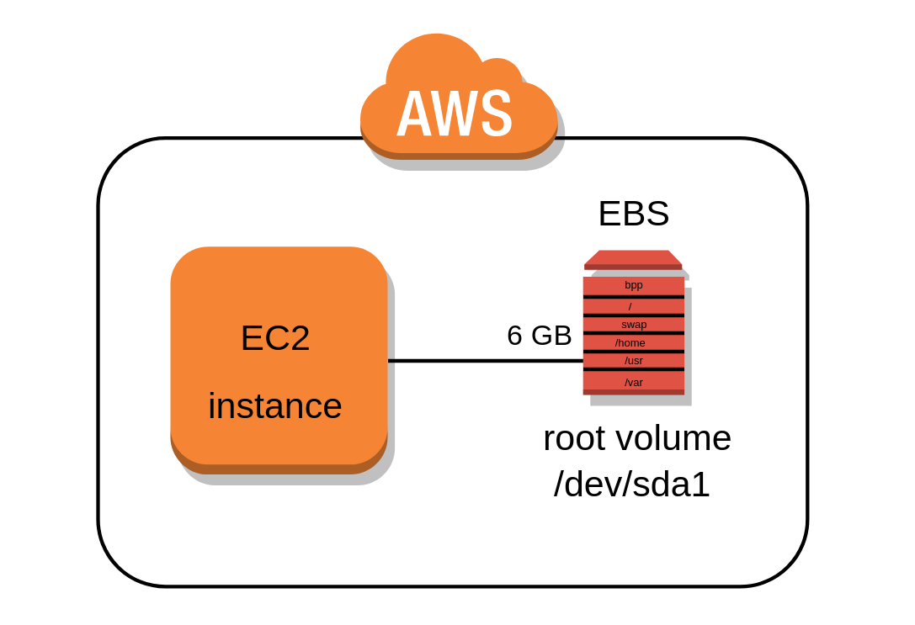

### EBS Volumes

An Amazon EBS volume is a durable, block-level storage device that you can attach to your instances. After you attach a volume to an instance, you can use it as you would use a physical hard drive. You can use EBS volumes as primary storage for data that requires frequent updates, such as the system drive for an instance or storage for a database application.

* EBS volumes are created in a specific **Availability Zone**, and can then be attached to any instances in that same Availability Zone.

### EBS Snapshots

ou can back up the data on your Amazon EBS volumes to **Amazon S3** by taking point-in-time snapshots. Snapshots are incremental backups, which means that only the blocks on the device that have changed after your most recent snapshot are saved.

### How to Create an EBS Volume for AWS EC2

1. Sign into AWS using your administrator account.
2. Navigate to the EC2 Console.
3. Choose a EC2 setup region from the Region drop-down list at the top of the page.
4. Select Volumes in the Navigation pane.
5. Click Create Volume.
6. Click Create.
7. Choose Actions→ Create Snapshot.
8. Type EBS.Backup in the Name field, type Test Backup in the Description field, and then click Create.
9. Click Close. The volume is ready to use.

When you finish this example, you can delete the volume you created by selecting its entry in the list and choosing Actions →Delete Volume. In a real-world setup, you can attach this volume to any EC2 instance or detach it when it’s no longer needed.

### References

* [AWS EBS Documentation](https://aws.amazon.com/ebs/?ebs-whats-new.sort-by=item.additionalFields.postDateTime&ebs-whats-new.sort-order=desc)

Day 7

**Unix**

# **Unix**

Unix is a family of operating systems that derive from one built in the 1970s at Bell Labs by AT&T. The current owner of the Unix license is The Open Group, however, Novell, Inc currently holds the copyrights. Linux operating systems and OS X operating systems are based on Unix. One of Unix's standard features is the command-line shell that is used to interface with the operating system. In Linux, this shell is commonly Bash.

## **Bash**

The Bourne Again Shell or Bash is based on the original Unix shell, which was called sh. Bash is compatible with sh and incorporates other features as well. Bash was created in 1989.

**Commands**

# **Commands**

In this section, we'll be covering some basic Unix commands. Before we begin, we should cover the basic aliases for locations in your file system. A file system is generally comprised of a directory, or folder, that itself can contain files and directories in a tree structure. The top-level directory is known as the root directory and it is the folder that contains all of the other folders on the drive partition you are currently accessing. In Unix, your root directory is represented by the / character. For example, if you wished to change directory to the root directory from anywhere on the partition, you would issue the following command: cd /

That's all well and good, but what about the directory you're currently in? The . character represents the current directory. Furthermore, .. represents the parent directory, so if you wanted to copy everything from the current directory up to the directory immediately above it, you would issue the following command: cp -r . ..

In Unix, we also have a directory called the home directory. This directory is usually the one that our terminal starts in and it is where our personal files are generally stored. This directory is represented by the ~ character.

Now, let's talk about some Unix commands:

## **Arguments and Flags**

In Unix, commands can be modified in two ways.

1. Commands can have arguments. Arguments given to a command take the form of strings written after the command. ex. command arg1 arg2 arg3
2. Commands can have flags. Flags are special arguments given to a command. There are two kinds of flags in Unix, short-hand or character flags, a single character (or group of characters), prefixed by a single dash -c, and full flags, the full name of the flag, prefixed by a double dash --flag.

Arguments to your command usually represent variables or targets for your command, and flags usually represent options you wish to enable for your command.

Ex. The following two commands do the same thing:

cp -r hi bye

cp --recursive hi bye

The above commands copy the contents of the hi directory to the bye directory recursively, using the -r and --recursive flags. This means that the cp command has been told to copy the contents of a directory instead of it's default mode which copies a specific file.

hi and bye are arguments to the command.

## **The Most Important Command**

man - The manual command will print to the terminal the manual for using a particular command. If you are unsure what flags or arguments a command takes, you simply type man command. For example, if you wished to see the manual for the copy command, you would issue the command: man cp

## **Directory Commands**

* cd - The change directory command allows us to navigate to a different directory on the drive.
  + go to root directory: cd /
  + go to home directory: cd or cd ~
  + navigate one directory up: cd ..
  + navigate into the hi directory, which is inside the bye directory: cd ./bye/hi
  + change to the previous directory: cd -
* ls - The list directory command allows us to see the contents of a particular directory. When given no arguments, it lists the contents of the current directory. The -a flag allows you to see hidden items in the directory.
  + list the contents of the current directory: ls
  + list the contents of the hi directory: ls hi or ls ./hi
  + list the contents of the directory including the "hidden" contents: ls -a
* mkdir - The make directory command allows us to create a new directory. mkdir takes an argument representing the name of the directory you wish to create.
  + create a directory named hi: mkdir hi
* pwd - The print working directory command prints the full name of the directory you are currently working in. For example, if you were working in the home directory inside of the root directory the output of pwd might be /home.

## **General Purpose Commands**

* su - The substitute user command allows you to switch users. With no argument, this defaults to the root user, which has higher priveleges. This can be useful if you need to perform multiple commands with elevated priveleges but is generally considered to be bad practice in preference to sudo, for administrative logging purposes.
* sudo - the sudo command allows you to run a particular command as the root user.
* clear - the clear command usually prints a number of blank lines such that all previous commands are no longer on the screen. There is a shortcut for this command, ctrl-l
* echo - the echo command will print a string or the result of a command to the console.
* > - The > operator will redirect the output of a command to a file. The file will be created or overwritten if it already exists. ex. ls . > log.txt
* >> - The >> operator acts the same way as the > operator but appends output to the file instead of overwriting if it exists.
* grep - the grep command prints any lines in a file or files that match a given pattern. By default, grep interprets the pattern as a basic regular expression.
  + Print all lines in hello.txt that contain the word goodbye: grep goodbye hello.txt

## **File Commands**

* cat - the concatenate command prints the contents of a file to the console. cat hello.txt
* head - the head command prints the first ten lines of a file to the console. head hello.txt
* tail - the tail command prints the last ten lines of a file to the console. tail hello.txt
* touch - the touch command allows you to modify the timestamp of a file. This command is usually used to create empty files, as an empty file is created if touch is given a file name that does not exist. touch hello.txt
* cp - the copy command creates a copy of the specified file at the location specified. If the recursive glag is used, it will operate on directories.
  + copy a hello.txt to goodbye.txt: cp hello.txt goodby.txt
  + copy the hello directory to the goodbye directory: cp -r hello goodbye
* mv - the move command will rename or move a file or entire directory with the recursive flag.
  + rename a hello.txt to goodbye.txt: mv hello.txt goodbye.txt
  + move hello.txt to the goodbye directory: mv hello.txt goodbye/.
  + rename the hello directory to goodbye: mv -r hello goodbye
* rm - the remove command will delete a file. If you use the recursive flag, it can delete a directory. The force flag will cause the command to delete files without prompting the user if there are warnings. The command rm -rf . is extremely dangerous.
  + remove hello.txt: rm hello.txt
  + remove the hello directory: rm -r hello
* wc - the word count command will print the number of words in a file. This command has several flags available
  + -c, --bytes - prints the byte count
  + -m, --chars - prints the character count
  + -l, --lines - prints the lines
  + -w, --words - prints the word count (default)
* ln - the link command creates a link between files. This allows you to make a shortcut to a file in one location without copying it over.

**Environment Variables**

# **Environment Variables**

Environment variables are values that are accessible in an entire working environment. In Unix, these values are set in the shell when it is started. For example, your home directory is an environment variable called $HOME. If you wish to see the value of a particular environment variable, you can use the echo command like so: echo $HOME.

To set your own environment variables, you can use the export command. For example, if you wanted to create an environment variable to store the password to your server, you could issue the following:

export SERVER\_PASS=password

echo $SERVER\_PASS

However, if you issue the above command into your console, when you close the shell and open it again, your environment will no longer be present. To keep these environment variables, you will have to place the command in one of your startup files, usually

~/.bashrc

You can also remove environment variables with the unset command:

unset SERVER\_PASS

echo $SERVER\_PASS

## **Practical Uses**

So, what's the point of having environment variables? They have several different uses that we can discuss.

### PATH

The PATH variable is one of the most commonly used environment variables, and it typically already exists on your computer. The reason for this is that it is used to reference the locations of software installations on your machine, especially software that requires certain commands that can be used in the terminal. For example, when you install Git, your machine needs to know where it is installed so that when you try to run a git command, it knows what code it's supposed to run. Usually this variable is set automatically when you install these kinds of software, but occasionally you need to update or change it yourself, in which case it's important to be aware that it exists and how to do so.

### Server Secrets

Environment variables are a common place to store things like database connection info, credentials, and tokens. When running code on a server, that code may need this information to run, and having the code reference environment variables rather than storing this information directly in the code or in a file makes it easier to modify the variables easily as needed and prevent situations like accidentally pushing credentials to a public Git repository. This makes them slightly safer because that information doesn't risk leaving the computer that the environment variables are on - however, they are still relatively easy to access, so you should be careful not to store sensitive, unencrypted data this way in a production environment.

## **On Windows**

If you need to work with environment variables on Windows, you can either do so using PowerShell or editing them via settings.

* [Using PowerShell to work with environment variables](https://docs.microsoft.com/en-us/powershell/module/microsoft.powershell.core/about/about_environment_variables?view=powershell-7.2)
* [Working with environment variables in Windows 10 via settings](https://www.minitool.com/news/environment-variables-windows-10-005.html)

**File Permissions**

# **File Permissions**

In Unix, file permissions can become very important. Every file in Unix has three types of permissions.

1. Owner permissions - What the owner of the file is allowed to do to the file.
2. Group permissions - What the group of users that the file belongs to is allowed to do to the file.
3. Other (world) permissions - What everyone else is allowed to do to the file.

Each type of permission can have any combination of read (r or 4), write (w or 2), and execute (x or 1) permissions. You can represent these permissions as either a number or a string of characters. For example, someone with read and write permissions has 6 or rw permissions.

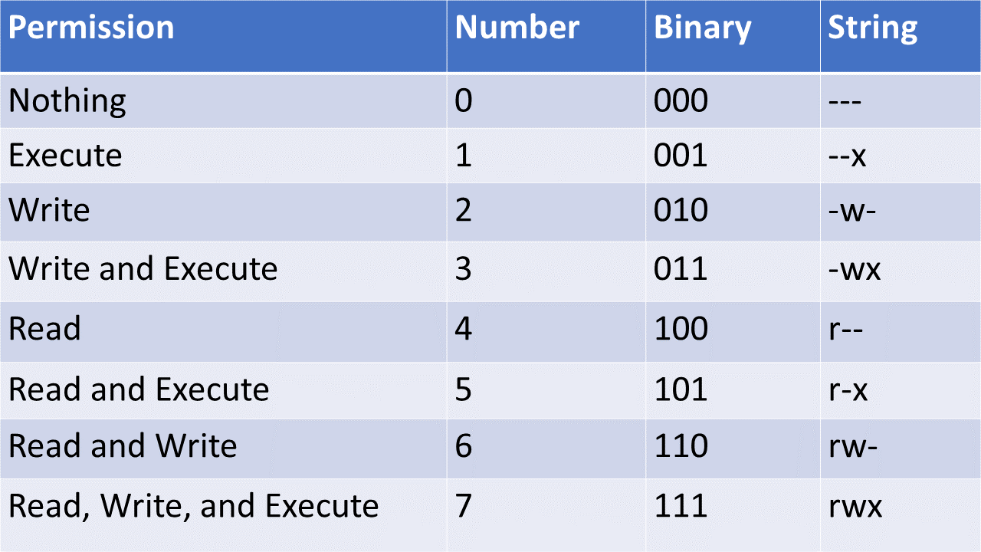

## **Viewing permissions**

You can see the permissions of files in a directory by using the -l flag on the ls command to get it to print the "long listing format"

ls -l .

## **Changing permissions**

You can change the permissions on a file using the chmod or change file mode bits command.

If you are using the numbers, it is as simple as specifying the correct permissions for the owner, groups, and other types and issuing the command targeting the file. For example, if I wished the owner to have read, write, and execute, groups to have read and execute, and other to have read permissions on hello.text I would issue the following command:

chmod 754 hello.txt

Otherwise, if you are using the strings, you have to specify which groups you are granting or revoking access to. Owner (u), group (g), and other (o) can be specified or all (a) can be used. The + indicates a granted privilege, - indicates a revoked privilege, and = allows you to set privileges.

Examples:

# Everyone has all permissions

chmod a+rwx hello.txt

# Revoke write access to other

chmod o-w hello.txt

# Set group access to be the same as other

chmod g=o hello.txt

**Package Managers**

# **Package Managers**

In Unix, if you wish to install software, you generally use a package manager. There are many package managers available and we will talk about a few.

## **RPM**

The Red Hat Package Manager or RPM is a package management system that manages .rpm files. It was created for Red Hat Linux but is used in many distributions.

## **APT**

Advanced Package Tool or APT is a package manager used on many Linux distributions. It allows you to retrieve, configure, and install/uninstall software packages.

## **yum**

The Yellowdog Updater, Modified or yum is a package-management utility for computers running RPM. When you create an EC2 using an Amazon Linux AMI, yum is installed.

As you are most likely to run into yum when you are working with Amazon linux, here are a few examples:

# update installed pacakges

sudo yum update

# Install git

sudo yum install git

# Uninstall git

sudo yum remove git

## **dpkg**

Debean Package is a low-level tool that manages .deb files. It was created for Debian and its derivatives.

**Command-Line Text Editors**

# **Command-line Text Editors**

You can write files in the shell by making use of built-in text editors such as nano and vim or vi.

## **Guides**

* [Beginner's Guide to Nano](https://www.howtogeek.com/howto/42980/the-beginners-guide-to-nano-the-linux-command-line-text-editor/)
* [Beginner's Guide to Vim](https://www.linux.com/training-tutorials/vim-101-beginners-guide-vim/)

## **Vi/Vim**

Vi originally came from the word "visual" as it was an early attempt at a more visual text editor. In order to use Vi, you can run vi file-path, and it will open in your terminal. Vi is set up such that there are two main "modes" that you can switch between - command mode and insert mode. When you first open Vi, you start in command mode, where you will be unable to type anything into the file. You can delete, copy, cut, paste, and undo, however, using the following commands:

* x to delete the character under the cursor.
* dd to delete the current line.
* v to mark the starting point of text you want to copy or cut.
* y to copy anything between the cursor and the place where you typed v.
* x to cut anything between the cursor and the place where you typed v.
* p to paste.
* u to undo.

After pressing i in command mode, you will switch to insert mode, where you can freely type in your file. After you've typed whatever you want to type, you can use the esc key to go back to command mode, and use any of the following commands:

* :w to save.
* :q to quit without saving.
* :wq to save and quit.
* :q! to force quit (if you've made changes that you don't want to save).

Vim is short for "Vi IMproved", and it is simply an improved version of Vi. You can use it by running vim file-path. Some of the improvements that were made include the ability to undo more than one action, open multiple windows, and more.

Vi/Vim are liked because they make complex text edits easy and fast. Once you get comfortable with the commands and switching between modes, it's a quick, light tool, great for performing for complex edits efficiently, although there is more of a learning curve.

## **Nano**

Open a file using Nano by running nano file-path. A key feature of Nano is that it shows you a list of useful commands right at the bottom of the terminal which makes it easy to use, especially for beginners. Most commands use the CTRL key, marked by ^ in the list. For example, pressing CTRL+G (Get Help) will show all commands.

Unlike Vi/Vim, Nano does not feature different modes - insertion and commands can both be done without needing to switch anything. This, along with the list of commands on the bottom, make the editor easy to use, especially for beginners and/or those who are more accustomed to modern GUI text editors.

**Overview**

## **Intro to SQL**

SQL stands for **Structured Query Language** - it is a domain-specific language for working with certain databases called relational databases. SQL is not a programming language, although there are extensions to the specification like PL/SQL that add familiar programming constructs. Instead, it is an English-like syntax that lets developers and database administrators abstract away the process of manipulating data and focus on the WHAT instead of HOW in the database.

Before we understand more about SQL, we need to understand what a relational database is. A relational database is a type of database that stores information in tables - that is, the data is stored in rows and columns, similar to a spreadsheet. Each row in the table is a record, and each record has properties which correspond to the different columns in the table. In order to provide a way for external entities to manipulate the database, we use a special kind of software called a relational database management system, or RDBMS.

Relational databases are often contrasted with another category of databases - non-relational databases. We won't go into the details of non-relational databases here, but you should be aware that there are major differences. Nonrelational databases do not store data within tables that relate to each other, and thus do not use SQL to interact with the databse.

RDBMS systems are one of the key components of any enterprise application or system. Why is this the case? Think about it - data by itself doesn’t mean a lot or even have intrinsic value. A lot of data thrown in a bucket would it mean be meaningless unless some kind of processing and analysis was done on it. oRelated data is what provides meaning and organizes the structure of data. For example, “an employee is in one or more departments”. We might have one table to store employees and another to store departments, and then define some relationship between them.

Normally, relational databases are used in an OLTP (OnLine Transaction Processing) environment, which means that the idea of having related data is preferable in a very transactional system, and that are normally row-based.

For non-transactional environments, the counter part is OLAP (OnLine Analytic Processing) systems, which are normally columnar-based, which is faster for reading but slower for manipulation.

**Data types**

## **Data Types**

When defining the properties of an entity in the database (i.e. the columns), you must specify the data type to store. Common SQL datatypes include:

#### **Numeric**

* BIT
* TINYINT
* BIGINT
* DECIMAL
* NUMERIC
* FLOAT
* REAL

#### **Date/Time**

* DATE
* TIMESTAMP
* DATETIME
* TIME
* YEAR

#### **Character/String**

* CHAR
* NCHAR
* VARCHAR
* NVARCHAR
* NTEXT

#### **Binary**

* BINARY
* VARBINARY
* IMAGE

#### **Miscellaneous**

* CLOB
* BLOB
* XML
* JSON

Each database vendor may support their own data types, or not support some of the ones listed above. Refer to the specific vendor documentation for more information.

### Conventions

SQL is a case-insensitive language, but the convention is to use UPPERCASE to refer to SQL keywords and lowercase for non-SQL specific entities (like table or column names). This helps distinguish between SQL keywords and other words. Also, for readability purposes we should split long commands or queries into multiple lines.

For example, this:

SELECT \* FROM table1

LEFT JOIN table2 ON table1.a = table2.b

WHERE table1.x < 5

AND table2.y > 8

ORDER BY table1.a DESC

is much more readable than:

SELECT \* FROM table1 LEFT JOIN table2 ON table1.a = table2.b WHERE table1.x < 5 AND table2.y > 8 ORDER BY table1.a DESC

**Defining Schema**

## **SQL Schema**

This module covers schemas, constraints, multiplicity, and normalization in RDBMS systems.

### Helpful References

* [Oracle Docs - Constraints](https://docs.oracle.com/cd/B19306_01/server.102/b14200/clauses002.htm#:~:text=Use%20a%20constraint%20to%20define,declare%20them%20in%20two%20ways.)

### Defining 'Schema'

A [database schema](https://en.wikipedia.org/wiki/Database_schema) refers to the formal **structure** of data defined in a relational database. This includes the various tables in the database as well as their columns, data types, and the relationship between tables. Schemas are enforced using **constraints** when defining tables, and we can visualize the schema of relational databases through entity-relationship diagrams, or **ERD**s.

NOTE: In Oracle databases, schema can also refer to a logical data storage structure. Oracle systems create a separate "schema" for each database user. However, we will refer to the original definition above from now on when we mention schema. Don't let this confuse you.

Day 8

**DDL - Data Definition Language**

## **DDL**

Data Definition Language statements are utilized to define the database schema or skeleton. It is how we implement the design structure of it. Some of the keywords in this sublanguage are:

* CREATE, to create new objects or tables.

**CREATE** **TABLE** TABLE\_NAME (C\_NAME C\_TYPE C\_SYZE [**NULL** **|** **NOT** **NULL**], [**CONSTRAINT**])

* ALTER, to modify existing objects or tables.

**ALTER** **TABLE** TABLE\_NAME [**ADD** **|** MODIFY **|** **DROP**] C\_NAME

**ALTER** **USER** IDENTIFIED **BY** PASSWORD

* DROP, to delete existing objects or tables.

**DROP** **TABLE** TABLE\_NAME [**CASCADE**]

* TRUNCATE, to delete all the data existing within a table leaving the skeleton of the table only.

TRUNCATE TABLE\_NAME

This is similar to performing DELETE TABLE with no where clause, the key difference is that TRUNCATE commits at the end of the operation.

All DDL operations **cannot be rolled back**, which means that any change made by these are permanent.

**DML - Data Manipulation Language**

## **DML**

Data Manipulation Language statements are used to perform CRUD operations on the actual data. Operations are normally performed by row in a relational database.

* INSERT, to insert a new row into a table.

**INSERT** **INTO** TABLE\_NAME **VALUES** (V1, V2, ..., VN)

**INSERT** **INTO** TABLE\_NAME (C1, C2, C3) **VALUES** (V1, V2, V3)

* UPDATE, to update one or more rows column values of a table that match a specific WHERE clause.

**UPDATE** TABLE\_NAME **SET** C1 **=** V1, ... , CN **=** VN **WHERE** X **=** Y

* DELETE, to delete one or more rows of a table that match a specific WHERE clause.

**DELETE** TABLE\_NAME **WHERE** [condition]

* SELECT, to obtain one or more rows of a table that match a specific WHERE clause. In ORACLE databases this one is considered DML. This is how we perform queries in a database.

**SELECT** C1, ..., CN **FROM** TABLE\_NAME [**table**] **WHERE** [condition] **GROUP** **BY** [expression]

**HAVING** [condition] **ORDER** **BY** **table**.field

**DQL - Data Query Language**

## **DQL**

Data Query Language, not really a sub-language within Oracle databases, is the sub language where only the SELECT statement exists. Remember, in Oracle the SELECT statement is considered as DML, but DQL could be an interview question.

### DQL Clauses

#### **GROUP BY & HAVING**

The GROUP BY clause will combine all rows by a column specified in a query and perform any aggregate functions which are stated.

* SELECT NAME, COUNT(NAME) FROM STUDENT GROUP BY (NAME)

The HAVING clause will pass another filter similar to the WHERE clause after everything has been filtered and grouped.

* SELECT NAME, COUNT(NAME) FROM STUDENT GROUP BY (NAME) HAVING COUNT(NAME) > 5;

If you try to perform this HAVING clause in a WHERE clause, a SQL error will be thrown, and it makes sense - the RDBMS doesn't want you to perform an aggregate function combining all rows, per each row. It's a performance safety measure.

### Scalar Functions

Scalar functions operate on individual values and will perform some operation per row, and can be used in the SELECT or WHERE clause.

* TO\_CHAR(DATE,'DATE\_FORMAT')
* TO\_DATE(DATE,'DATE\_FORMAT')
* UPPER('VALUE')
* LOWER('VALUE')

To write them in a query:

**SELECT** UPPER(NAME) **FROM** STUDENT;

**SELECT** NAME **FROM** STUDENT **WHERE** UPPER(NAME) **LIKE** 'P%'.

### Aggregate Functions

Aggregate functions operate on multiple values (multiple rows). These functions are used to combine (aggregate) the values existing in one column.

* MAX(COLUMN), which returns the max value on a column.
* MIN(COLUMN), which returns the minimum value on a column.
* AVG(COLUMN), which returns the average value of the column.
* SUM(COLUMN), which returns the sum of the column.
* COUNT(COLUMN), which returns the count of elements in a column.
* And many others.

These functions are used in the SELECT clause. They can't be used in the WHERE clause.

If there is more than one column being selected in the SELECT column section of a query which is not aggregating, a GROUP BY clause is required.

In order to perform similar WHERE clause Boolean operations with aggregate functions, the HAVING clause can be used.

**DCL - Data Control Language**

## **DCL**

Data Control Language statements are used to manage the security and control of database systems.

* GRANT, to grant any permissions to an existing user.

**GRANT** PERMISSION **TO** USERNAME

* REVOKE, to revoke any permissions of an existing user.

**REVOKE** PERMISSION **TO** USERNAME

**Constraints**

## **Constraints**

We can put integrity **constraints** on specific columns in our database when defining tables, which allow us to enforce the schema by ensuring consistency and integrity of the data in the table. The different constraints are listed below:

* PRIMARY KEY
* FOREIGN KEY
* NOT NULL
* UNIQUE
* CHECK
* DEFAULT
* AUTO INCREMENT

A **primary key** is a constraint that uniquely identifies a record in a table. Often, this constraint will be enforced on some sort of "ID" field, such as "employee\_id". A primary key is inherently composed of two other constraints - unique and not null. Thus, a primary key MUST be provided when inserting a record into a table, unless the RDBMS system is generating it automatically behind the scenes.

A **foreign key** constraint signifies that a column represents a reference to the primary key of another table. This allows us to create relationships between tables. For example, if we are modeling cars and the owners of those cars, we might have a Car table with an owner\_id foreign key that references the user\_id field in the People table. We can then lookup the owner of any car by fetching the owner\_id of the car and finding the matching user\_id in the People table.

A **not null** constraint simply enforces that all records must have a field for the column on which this constraint is applied. For example, we know that every person has a social security number, so we might want to consider placing a not null constraint on that field in our users table (assuming we want to store the social security numbers). This prevents users of the database from leaving the table in an inconsistent or invalid state. The **unique** constraint works similarly - records cannot be inserted if another record already has the same value for the column on which this is declared.

The **check** constraint provides a way of performing validation on values before records are entered into the table. For example, we may want to ensure that a bank account can never have a negative balance, so we might set a check constraint (CHECK (balance >= 0)).

Finally, a **default** constraint allows setting default values on columns for records that are inserted into the table.

Finally **Auto-increment** allows a unique number to be generated automatically when a new record is inserted into a table. Very often the primary key of a table needs to be created automatically, and we define that field as AUTO INCREMENT field. Following is the syntax for creating an AUTO INCREMENT field.

**CREATE** **TABLE** TableName (

Column1 DataType AUTO\_INCREMENT **PRIMARY** **KEY**,

Column2 DataType,

);

### Candidate and Composite Keys

Usually a primary key consists of a single column; however, sometimes we may have a scenario in which there could be multiple columns that together create a primary key to uniquely identify rows. We call these **candidate keys**. Once we identify the actual combination of columns to use as the primary key, we call this a **composite key**. For example, if you are modeling your CD collection, you might have fields such as track\_no, album\_id, and genre in the Track table. The track\_no itself cannot work as a primary key because many different albums can have a track #1, for example. So we would need to create a composite key here, consisting of the track\_no and the album\_id columns. Using both of these columns together we can find the specific track we are looking for.

## **Referential Integrity**

When we create table relationships as demonstrated above, it is important that our data remains in a consistent state throughout the database. For example, we never want a record on our class table to be pointing to a record in either the Teacher or the Student table that does not exist. We call enforcing this property as maintaining **referential integrity**. When we break referential integrity, we will find **orphan records** in the database - these are records whose foreign keys do not point to an existing record in the other table. One way of preventing this from occuring is by using a setting called **CASCADE DELETE** - when we enable this, deleting a record in the table will also cascade that operation and delete any records in tables that reference the that record via foreign keys.

**Table relationships / multiplicity**

## **Multiplicity**

As mentioned before, table relationships can be defined using foreign key constraints. There are several different kinds of relationships that exist between tables in relational databases:

* One to one
* One to Many / Many to One
* Many to Many

A one-to-one relationship means that each entity in the table only relates to a single entity in the other table. For example, if we are modeling a school, where each classroom has a single projector in it, we would want to make this relationship a one to one between the Classroom and the Projector tables. In our database, we can provide the classroom table a projector\_id foreign key and provide the projector table a classroom\_id foreign key. To enforce the one to one aspect, we should also apply a unique constraint on the foreign key columns. Otherwise, a user could add another projector record with the same classroom\_id as an existing record, and then our one to one relationship would be broken.

A one to many (or vice versa, many to one) relationship is where one entity can belong to, own, or otherwise relate to multiple other entities. In our school modeling example, a Student could have many books, so this would be a one to many relationship. To create this in the database, we add the foreign key **only on the many side of the relationship** - so a book entity would have a field such as student\_id as a foreign key to identify the owning student.

A many-to-many relationship implies a one-to-many relationship in both directions on the entities. For example, a Teacher can have many Students, but a Student could have many Teachers as well. In this case, **we cannot provide a direct link between the tables in the database - instead, we need to create what is called a junction table or bridge table to relate the two tables**. So, in our student-teacher example, we could create a Class table which contains two foreign keys - one that refers to the Teacher table's primary key and one that refers to the Student table's primary key. This creates a list of unique Teacher-Student mappings that can be used to look up which students a particular teacher teaches, or which teachers a particular student has. An example is shown below.

#### **Class Table**

| **ClassId** | **TeacherId** | **StudentId** |
| --- | --- | --- |
| 1 | 1 | 1 |
| 1 | 1 | 2 |
| 2 | 1 | 3 |
| 3 | 2 | 1 |
| 3 | 2 | 3 |

We can see above that Teacher 1 teaches both Student 1 and 2 in the same class. Teacher 2 teaches Student 1 and 3 in a different class. Teacher 1 also has another class where he just teaches Student 3.

**Normalization**

## **Normalization**

[**Normalization**](https://en.wikipedia.org/wiki/Database_normalization) refers to an optimization process of structuring a relational database in a way that reduces redundancy of data and improves data integrity and consistency. There are many different normal forms, which relate to the degree to which a database has been normalized. We will look at the first three normal forms, each of which build upon the previous:

* 1NF - must have a primary key, no repeating groups, and atomic columns
* 2NF - must already be in 1NF, plus have no partial dependencies
* 3NF - must already be in 2NF, plus have no transitive dependencies

The first normal form enforces that a table **must**:

* Have a primary key
* Each column should be as granular as possible (e.g. "Name" column should be broken up into: "First Name", "Last Name", "Middle Name", etc..)

To be in second normal form, a table must **also**:

* Cannot have columns that are dependent on only one part of the key
* If there are no composite primary keys, you are automatically in 2NF

Finally, to get to third normal form, a table must **also**:

* Not have transitive dependencies
* This means that if column C relates to column B which relates to column A which is the primary key, this is not in 3NF because C is related to the primary key but indirectly (it is a transitive dependency)

To advance into higher normal forms, we typically "break up" tables into multiple tables and relate them to each other via foreign keys.

A good way of remembering these normal forms in order is to remember the legal proceeding of swearing to tell the truth, the whole truth, and nothing but the truth. In relational databases, we must have **the key (1NF), the whole key (2NF), and nothing but the key (3NF)**.

Day 9

**TCL - Transaction Control Language**

## **TCL**

Transaction Control Language statements are utilized to manage transactions within a relational database.

* COMMIT, any DML operations that were executed before the statements will be persisted permanently.
* ROLLBACK, any DML operations between two COMMIT statements will be completely erased (something like Ctrl + Z that will stop only when it reaches last time you opened the specific file). Committed transactions cannot be rollbacked.
* SAVEPOINT, utilized to ROLLBACK to a specific point in time.

The general flow of using TCL could be as follows:

[Many DML Operations]

SAVEPOINT A

[Many DML Operations]

ROLLBACK TO A

**Atomicity**

## **ACID Properties**

Any amount of DML statements before a COMMIT statement is considered a **transaction**. After the COMMIT is done, the transaction should follow certain properties. Transactions are considered to be logical units of work - for example, transferring money from Person A's bank account to Person B's account. You should think about how to logically group your DML operations into transactions when writing code.

A transaction has 4 properties termed as [ACID](https://en.wikipedia.org/wiki/ACID) Properties:

* **A**tomicity - Atomicity means that either all of the transactions will execute successfully or none of them will.
* **C**onsistency – measurement of correctness Consistency means that constraints are enforced for every committed transaction. That indicates that all Keys, Data types, Checks, and Triggers are successful and no constraint violation is triggered.
* **I**solation - If two transactions are executing simultaneously/concurrently and working on the same data, then one transaction should not disturb the other transaction. Isolation guarantees that concurrently running transactions should not affect each other.
* **D**urability - Durability means that once a transaction is complete, it guarantees that all of the changes are recorded in the database. If our system is suddenly affected by a system crash or a power outage, then all unfinished committed transactions may be replayed.

In other words,

The properties of transactions should be as follows:

* **ATOMIC** - "All or nothing", if any statement on the transaction fails, the whole transaction fails.
* **CONSISTENT** - If the database was in a consistent state before the transaction, it should be after it.
* **ISOLATED** - One transaction shouldn't affect oth er transactions. It can be applied in different levels.
* **DURABLE** - Persisted data should be saved permanently, even in the case of power loss or catastrophic software or hardware failure.
  + Some RDBMS's have different approaches, even to recover from catastrophes (Oracle has special logs [Bitacora]).

### Isolation Levels

[Isolation](https://en.wikipedia.org/wiki/Isolation_(database_systems)) levels are applied in RDBMS to provide consistency and avoid certain read phenomena. The following isolation levels are presented from most to least isolated:

* Serializable
  + Allowed in Oracle
  + Read/Write locks
  + Applies range locks even in the WHERE clauses of a select statement
  + Phantom reads can't happen because of this
  + Table that is being read can't be modified until the reading is done (no INSERTS, no UPDATES, no DELETES)
* Repeatable Reads
  + Not used often
  + Read/Write locks
  + Doesn't provide range locks, that means phantom reads can happen
  + Doesn't lock the whole SELECT statement, nor INSERTS, nor UPDATES, nor DELETS
* Read Committed
  + Oracle default
  + Write only locks
  + Only data that is committed will be seen by other transactions
  + Dirty reads can't happen, but Phantom reads can
  + This is why it is recommended to not perform very long transactions
* Read Uncommitted
  + A disaster
  + Dirty reads are normal, any transaction can see any uncommitted data
  + Very inconsistent

## **Read Phenomena**

* Dirty Read: reading data that is uncommitted
* Non-repeatable read: when a row is read twice in a transaction and the values are different
* Phantom Read: reading data that is being added or modified by a running transaction

**Isolation**

## **ACID Properties**

Any amount of DML statements before a COMMIT statement is considered a **transaction**. After the COMMIT is done, the transaction should follow certain properties. Transactions are considered to be logical units of work - for example, transferring money from Person A's bank account to Person B's account. You should think about how to logically group your DML operations into transactions when writing code.

A transaction has 4 properties termed as [ACID](https://en.wikipedia.org/wiki/ACID) Properties:

* **A**tomicity - Atomicity means that either all of the transactions will execute successfully or none of them will.
* **C**onsistency - Consistency means that constraints are enforced for every committed transaction. That indicates that all Keys, Data types, Checks, and Triggers are successful and no constraint violation is triggered.
* **I**solation - If two transactions are executing concurrently and working on the same data, then one transaction should not disturb the other transaction. Isolation guarantees that concurrently running transactions should not affect each other.
* **D**urability - Durability means that once a transaction is complete, it guarantees that all of the changes are recorded in the database. If our system is suddenly affected by a system crash or a power outage, then all unfinished committed transactions may be replayed.

In other words,

The properties of transactions should be as follows:

* **ATOMIC** - "All or nothing", if any statement on the transaction fails, the whole transaction fails.
* **CONSISTENT** - If the database was in a consistent state before the transaction, it should be after it.
* **ISOLATED** - One transaction shouldn't affect other transactions. It can be applied in different levels.
* **DURABLE** - Persisted data should be saved permanently, even in the case of power loss or catastrophic software or hardware failure.
  + Some RDBMS's have different approaches, even to recover from catastrophes (Oracle has special logs [Bitacora]).

### Isolation Levels

[Isolation](https://en.wikipedia.org/wiki/Isolation_(database_systems)) levels are applied in RDBMS to provide consistency and avoid certain read phenomena. The following isolation levels are presented from most to least isolated:

* Serializable
  + Allowed in Oracle
  + Read/Write locks
  + Applies range locks even in the WHERE clauses of a select statement
  + Phantom reads can't happen because of this
  + Table that is being read can't be modified until the reading is done (no INSERTS, no UPDATES, no DELETES)
* Repeatable Reads
  + Not used often
  + Read/Write locks
  + Doesn't provide range locks, that means phantom reads can happen
  + Doesn't lock the whole SELECT statement, nor INSERTS, nor UPDATES, nor DELETS
* Read Committed
  + Oracle default
  + Write only locks
  + Only data that is committed will be seen by other transactions
  + Dirty reads can't happen, but Phantom reads can
  + This is why it is recommended to not perform very long transactions
* Read Uncommitted
  + A disaster
  + Dirty reads are normal, any transaction can see any uncommitted data
  + Very inconsistent

## **Read Phenomena**

* Dirty Read: reading data that is uncommitted
* Non-repeatable read: when a row is read twice in a transaction and the values are different
* Phantom Read: reading data that is being added or modified by a running transaction

**Consistency**

## **ACID Properties**

Any amount of DML statements before a COMMIT statement is considered a **transaction**. After the COMMIT is done, the transaction should follow certain properties. Transactions are considered to be logical units of work - for example, transferring money from Person A's bank account to Person B's account. You should think about how to logically group your DML operations into transactions when writing code.

A transaction has 4 properties termed as [ACID](https://en.wikipedia.org/wiki/ACID) Properties:

* **A**tomicity - Atomicity means that either all of the transactions will execute successfully or none of them will.
* **C**onsistency - Consistency means that constraints are enforced for every committed transaction. That indicates that all Keys, Data types, Checks, and Triggers are successful and no constraint violation is triggered.
* **I**solation - If two transactions are executing concurrently and working on the same data, then one transaction should not disturb the other transaction. Isolation guarantees that concurrently running transactions should not affect each other.
* **D**urability - Durability means that once a transaction is complete, it guarantees that all of the changes are recorded in the database. If our system is suddenly affected by a system crash or a power outage, then all unfinished committed transactions may be replayed.

In other words,

The properties of transactions should be as follows:

* **ATOMIC** - "All or nothing", if any statement on the transaction fails, the whole transaction fails.
* **CONSISTENT** - If the database was in a consistent state before the transaction, it should be after it.
* **ISOLATED** - One transaction shouldn't affect other transactions. It can be applied in different levels.
* **DURABLE** - Persisted data should be saved permanently, even in the case of power loss or catastrophic software or hardware failure.
  + Some RDBMS's have different approaches, even to recover from catastrophes (Oracle has special logs [Bitacora]).

### Isolation Levels

[Isolation](https://en.wikipedia.org/wiki/Isolation_(database_systems)) levels are applied in RDBMS to provide consistency and avoid certain read phenomena. The following isolation levels are presented from most to least isolated:

* Serializable
  + Allowed in Oracle
  + Read/Write locks
  + Applies range locks even in the WHERE clauses of a select statement
  + Phantom reads can't happen because of this
  + Table that is being read can't be modified until the reading is done (no INSERTS, no UPDATES, no DELETES)
* Repeatable Reads
  + Not used often
  + Read/Write locks
  + Doesn't provide range locks, that means phantom reads can happen
  + Doesn't lock the whole SELECT statement, nor INSERTS, nor UPDATES, nor DELETS
* Read Committed
  + Oracle default
  + Write only locks
  + Only data that is committed will be seen by other transactions
  + Dirty reads can't happen, but Phantom reads can
  + This is why it is recommended to not perform very long transactions
* Read Uncommitted
  + A disaster
  + Dirty reads are normal, any transaction can see any uncommitted data
  + Very inconsistent

## **Read Phenomena**

* Dirty Read: reading data that is uncommitted
* Non-repeatable read: when a row is read twice in a transaction and the values are different
* Phantom Read: reading data that is being added or modified by a running transaction

**Durability**

## **ACID Properties**

Any amount of DML statements before a COMMIT statement is considered a **transaction**. After the COMMIT is done, the transaction should follow certain properties. Transactions are considered to be logical units of work - for example, transferring money from Person A's bank account to Person B's account. You should think about how to logically group your DML operations into transactions when writing code.

A transaction has 4 properties termed as [ACID](https://en.wikipedia.org/wiki/ACID) Properties:

* **A**tomicity - Atomicity means that either all of the transactions will execute successfully or none of them will.
* **C**onsistency - Consistency means that constraints are enforced for every committed transaction. That indicates that all Keys, Data types, Checks, and Triggers are successful and no constraint violation is triggered.
* **I**solation - If two transactions are executing concurrently and working on the same data, then one transaction should not disturb the other transaction. Isolation guarantees that concurrently running transactions should not affect each other.
* **D**urability - Durability means that once a transaction is complete, it guarantees that all of the changes are recorded in the database. If our system is suddenly affected by a system crash or a power outage, then all unfinished committed transactions may be replayed.

In other words,

The properties of transactions should be as follows:

* **ATOMIC** - "All or nothing", if any statement on the transaction fails, the whole transaction fails.
* **CONSISTENT** - If the database was in a consistent state before the transaction, it should be after it.
* **ISOLATED** - One transaction shouldn't affect other transactions. It can be applied in different levels.
* **DURABLE** - Persisted data should be saved permanently, even in the case of power loss or catastrophic software or hardware failure.
  + Some RDBMS's have different approaches, even to recover from catastrophes (Oracle has special logs [Bitacora]).

### Isolation Levels

[Isolation](https://en.wikipedia.org/wiki/Isolation_(database_systems)) levels are applied in RDBMS to provide consistency and avoid certain read phenomena. The following isolation levels are presented from most to least isolated:

* Serializable
  + Allowed in Oracle
  + Read/Write locks
  + Applies range locks even in the WHERE clauses of a select statement
  + Phantom reads can't happen because of this
  + Table that is being read can't be modified until the reading is done (no INSERTS, no UPDATES, no DELETES)
* Repeatable Reads
  + Not used often
  + Read/Write locks
  + Doesn't provide range locks, that means phantom reads can happen
  + Doesn't lock the whole SELECT statement, nor INSERTS, nor UPDATES, nor DELETS
* Read Committed
  + Oracle default
  + Write only locks
  + Only data that is committed will be seen by other transactions
  + Dirty reads can't happen, but Phantom reads can
  + This is why it is recommended to not perform very long transactions
* Read Uncommitted
  + A disaster
  + Dirty reads are normal, any transaction can see any uncommitted data
  + Very inconsistent

## **Read Phenomena**

* Dirty Read: reading data that is uncommitted
* Non-repeatable read: when a row is read twice in a transaction and the values are different
* Phantom Read: reading data that is being added or modified by a running transaction

**Setting up the Database Driver**

### Database JDBC Drivers

Because JDBC is a Java language API, it is database agnostic. It uses database drivers which implement the interfaces defined in the JDBC API for the given database. For example, to connect with an Oracle database, you would use an [OJDBC driver](https://www.oracle.com/technetwork/database/features/jdbc/default-2280470.html). Other database vendors have different drivers which implement the JDBC API.

Many JDBC drivers are available through Maven's central repository and can be added as a dependency in the pom.xml file. Oracle is a special exception due to license restrictions. You must accept the licese agreement, download, and install it to your local Maven repository ([tutorial here](https://www.mkyong.com/maven/how-to-add-oracle-jdbc-driver-in-your-maven-local-repository/) before you can add it to the pom.xml file.

Finally, in your application code, you can register the driver using:

try {

Class.forName("oracle.jdbc.driver.OracleDriver");

}

catch(ClassNotFoundException e) {

System.out.println("Can't load driver class!");

}

This step is only necessary for drivers prior to JDBC 4.0 (released with Java SE 6). After JDBC 4.0, drivers will be autoloaded if they are included in the classpath.

**Connection Interface**

## **Connection Interface**

java.sql.Connection interface represents a session between java application and database. All SQL statements are executed and results are returned with in the context of a Connection object.

We can use the DriverManager class to get a Connection to the database, given that we have the JDBC URL, username, and password. Generally these parameters should be stored in an external configuration file that can be loaded dynamically and changed without affecting the application code.

**try** (**Connection** conn = **DriverManager**.**getConnection**(DB\_URL,USERNAME,PASSWORD)) {

// more code goes here

} **catch** (**SQLException** e) {}

Alternatively, the DataSource interface could be used to make connections and is covered extensively in this [Oracle tutorial](https://docs.oracle.com/javase/tutorial/jdbc/basics/sqldatasources.html).

It's always a good idea to close your resources - here we've used the try-with-resources syntax to automatically close the Connection being created after the block ends.

#### **Autocommit mode**

By default, when a connection is created it is in auto-commit mode, so every SQL statement acts as a transaction and is committed immediately after execution. In order to manually group statements into a transaction, simply call:

**Connection** conn = **DriverManager**.**getConnection**(DB\_URL,USERNAME,PASSWORD);

conn.**setAutoCommit**(false);

// execute some SQL statements...

con.**commit**();

#### **JDBC String**

The database URL is an address pointing to the database to be used, also known as the JDBC String. The format of this URL varies between database vendors, as shown in the table below:

| **RDBMS** | **JDBC driver** | **URL format** |
| --- | --- | --- |
| MySQL | com.mysql.jdbc.Driver | jdbc:mysql://hostname/databaseName |
| Oracle | oracle.jdbc.driver.OracleDriver | jdbc:oracle:thin:@hostname:portNumber:databaseName |
| SQLServer | com.microsoft.sqlserver.jdbc.SQLServerDriver | jdbc:sqlserver://serverName:portNumber;property=value |
| PostgreSQL | org.postgresql.Driver | jdbc:postgresql://hostname:port/databaseName |

**Interfaces of JDBC**

# **JDBC Classes and Interfaces**

JDBC stands for Java Database Connectivity. It is a relatively low-level API used to write Java code that interacts with relational databases via SQL.

The [JDBC classes and interfaces](https://docs.oracle.com/javase/8/docs/api/index.html?java/sql/package-summary.html) are located in the java.sql and javax.sql packages. There are several key classes and interfaces that are commonly encountered when writing JDBC code:

* DriverManager class - to make a connection with a database driver
* DataSource interface - for retrieving connections, an alternative to DriverManager
* Connection interface - represents a physical connection with a database
* SQLException class - a general exception thrown when something goes wrong when accessing the database
* Statement interface - used for executing static SQL statements
* PreparedStatement interface - represents pre-compiled SQL statements
* CallableStatement interface - used to execute stored procedures
* ResultSet interface - represents data returned from the database

## **Creating a Database Connection**

In order to interact with a database, we need to do several things:

1. Register the JDBC driver
2. Open a connection using:

* Database URL
* Username
* Password

1. Execute some SQL statement using either:

* Statement
* PreparedStatement
* CallableStatement

1. Retrieve the results that are returned in a ResultSet object

**Simple & Prepared Statements**

# **Statement and PreparedStatement Interfaces**

Statement interface is used for executing static SQL statements. PreparedStatement interface is used for executing pre-compiled SQL statements.

Once we have the Connection object, we can write our SQL and execute it:

**Statement** stmt = conn.**createStatement**();

**String** sql = "SELECT \* FROM employees";

**ResultSet** rs = stmt.**executeQuery**(sql);

Alternatively, a PreparedStatement can be used. This interface gives us the flexibility of specifying parameters with the ? symbol. It also protects against [SQL injection](https://en.wikipedia.org/wiki/SQL_injection) when user input is used by pre-compiling the SQL statement.

**PreparedStatement** ps = conn.**prepareStatement**();

**String** sql = "SELECT \* FROM employees WHERE age > ? AND location = ?";

ps.**setInt**(1, 40);

ps.**setString**(2, "New York");

**ResultSet** rs = ps.**executeQuery**(sql);

The Statement and PreparedStatement also have additional methods for sending SQL, including:

* .execute() - for any kind of SQL statement, returns a boolean
* .executeUpdate() - for DML statements, returns an int which is the number of rows affected

### Retreiving Results

Results from an SQL query are returned as a ResultSet, which can be iterated over to extract the data:

**List**<**Employee**> empList = **new** **ArrayList<>**();

**while** (rs.**next**()) {

**int** id = rs.**getInt**("id");

**String** name = rs.**getString**("first\_name");

empList.**add**(**new** **Employee**(id, name));

}

**Callable Statement**

## **CallableStatment Interface**

CallableStatement interface is used to execute stored procedures. You create an instance of a CallableStatement by calling the prepareCall() method on a connection object. A CallableStatement can return one ResultSet object or multiple ResultSet objects.

//con is the Connection object

//It calls the procedure 'myprocedure' that receives 2 arguments.

**CallableStatement** stmt=con.**prepareCall**("{call myprocedure(?,?)}");

### Example:

In this example, we are going to call the stored procedure INSERTROWS that receives id and name as the parameter and inserts it into the table STUDENT.

The STUDENT table structure is given below:

**create** **table** STUDENT(id number(10), name varchar2(200));

And INSERTROWS stored procedure looks like:

**create** **or** replace **procedure** "INSERTROWS"

(id **IN** NUMBER,

name **IN** VARCHAR2)

**is**

**begin**

**insert** **into** user420 values(id,name);

**end**;

/

#### **Accessing Stored Procedures**

Following code inserts new records into the STUDENT table by calling the above created stored procedure INSERTROWS, using a callable statement.

**public** **static** **void** **main**(**String**[] args) **throws** **Exception**{

//Registering the Driver

**Class**.**forName**("oracle.jdbc.driver.OracleDriver");

//Getting the connection

**Connection** con=**DriverManager**.**getConnection**( "jdbc:oracle:thin:@localhost:1521:xe","system","oracle");

//Preparing a CallableStateement

**CallableStatement** stmt=con.**prepareCall**("{call INSERTROWS(?,?)}");

stmt.**setInt**(1,1011);

stmt.**setString**(2,"John");

stmt.**execute**();

**System**.out.**println**("success");

}

}

**Properties file**

## **JDBC Properties Files**

## **References**

* [Properties and Environment Oracle tutorial](https://docs.oracle.com/javase/tutorial/essential/environment/properties.html)

## **JDBC Connection**

When making a JDBC connection to a database you may have noticed the code typically looks like this.

**DriverManager**.**getConnection**(URL, CONNECTION\_USERNAME, CONNECTION\_PASSWORD);

But, where are we getting those values? Well up until now you have probably seen them as plain text Strings. As you can imagine this is not secure and requires you to change the code anytime the password etc. is updated.

To solve this problem developers began to collect all of this information into properties files. A properties file stores information as key value pairs, each on their own line; the file has a .properties extension. For instance you might have,

URL=jdbc:postgresql://localhost:5432/PubHub

CONNECTION\_USERNAME=user

CONNECTION\_PASSWORD=password

Then you can use the Properties class and FileInputStream to use these properties in your class.

**FileInputStream** fileStream = **new** **FileInputStream**("pathtopropertiesfile");

**Properties** properties = **new** **Properties**();

properties.**load**(fileStream);

URL = properties.**getProperty**("URL");

CONNECTION\_PASSWORD = properties.**getProperty**("CONNECTION\_PASSWORD");

CONNECTION\_USERNAME = properties.**getProperty**("CONNECTION\_USERNAME");

Great! So this solves some of our problem, but we are still saving our information as plain text. Now it's just in a different kind of file.

**Aside**: If you are using this method to read in properties for a web application that will be deployed on a server, you may need to use a different approach. When reading in a file, if you use a relative path it will be relative to the working directory. This can be unpredictable when it comes to servers, so instead we can use this method in those instances.

**Properties** prop = **new** **Properties**();

**try** {

**InputStream** dbProps = **ConnectionUtil**.**class**.**getClassLoader**().**getResourceAsStream**("database.properties");

prop.**load**(dbProps);

} **catch** (**Exception** e) {

**LogUtil**.**logException**(e, **ConnectionUtil**.**class**);

}

So the next step is to include the information as System Environment Variables instead of just plain text.

Unfortunately Java on its own will not parse our System environment variables into the application.properties file. When you begin using certain frameworks like Spring you may be able to change your .properties file to look like this.

URL=${URL}

CONNECTION\_USERNAME=${CONNECTION\_USERNAME}

CONNECTION\_PASSWORD=${CONNECTION\_PASSWORD}

However for now we can simply use our properties to read in values from the System through the System library.

URL=url

CONNECTION\_USERNAME=connectionUsername

CONNECTION\_PASSWORD=connectionPassword

Then on the system we would need to make sure to create url, connectionUsername, and connectionPassword respectively. You can do this in Eclipse if you don't want to set them system wide. Simply go to Run Configurations and tab over to the Environment tab.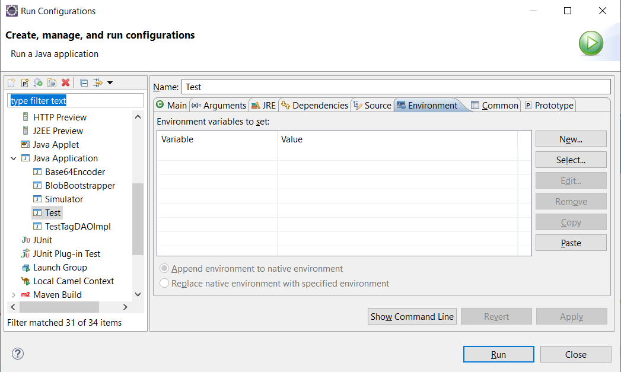

Then in our Java class we'll use our values to read in from the System variables.

**FileInputStream** fileStream = **new** **FileInputStream**("pathtopropertiesfile");

**Properties** properties = **new** **Properties**();

properties.**load**(fileStream);

**String** url = properties.**getProperty**("URL");

**String** password = properties.**getProperty**("CONNECTION\_PASSWORD");

**String** username = properties.**getProperty**("CONNECTION\_USERNAME");

URL = **System**.**getenv**(url);

CONNECTION\_PASSWORD = **System**.**getenv**(password);

CONNECTION\_USERNAME = **System**.**getenv**(username);

And then we should be good to go!

**Design Pattern: Data Access Object (DAO)**

## **Data Access Objects**

When writing JDBC code, the application business logic may get mixed in with JDBC boilerplate code for querying the database, resulting in hard to read spaghetti code. One way to address this problem is to logically separate the code that accesses the database into Data Access Objects - this is referred to as the **DAO design pattern**.

To use the DAO design pattern, define an interface which declares methods through which the database will be queried. Then, concrete implementation classes can implement the interface and contain the data access logic to return the required data.

For example, if we have an Employee table in our database we'd like to query, we would create a EmployeeDAO interface:

**public** **interface** **EmployeeDAO** {

// define some CRUD operations here

**public** **List**<**Employee**> **getAllEmployees**();

**public** **List**<**Employee**> **getEmployeesByLocation**(**String** location);

**public** **void** **updateEmployeeById**(**int** id);

**public** **void** **deleteEmployeeById**(**int** id);

**public** **void** **addEmployee**(**Employee** e);

}

This interface would be implemented for a specific database - e.g. Oracle:

**public** **class** **EmployeeDAOImplOracle** **implements** **EmployeeDAO** {

**public** **List**<**Employee**> **getAllEmployees**() {

**List**<**Employee**> list = **new** **ArrayList<>**();

// JDBC code here...

**return** list;

};

**public** **List**<**Employee**> **getEmployeesByLocation**(**String** location) {

**List**<**Employee**> list = **new** **ArrayList<>**();

// JDBC code here...

**return** list;

};

**public** **void** **updateEmployeeById**(**int** id) {

// JDBC code here...

};

**public** **void** **deleteEmployeeById**(**int** id) {

// JDBC code here...

};

**public** **void** **addEmployee**(**Employee** e) {

// JDBC code here...

};

}

Now whenever we need to query the Employee table in the database, we have a simple, clean interface which abstracts the data access logic:

**EmployeeDAO** dao = **new** **EmployeeDAOImplOracle**();

**List**<**Employee**> allEmpls = dao.**getAllEmployees**();

allEmpls.**forEach**( e -> **System**.out.**println**(e));

**List**<**Employee**> **NYEmpls** = dao.**getEmployeesByLocation**("New York");

**NYEmpls**.**forEach**( e -> **System**.out.**println**(e));

Also, we can simply swap out the concrete class EmployeeDAOImplOracle for another database-specific class if we need to at some point in the future, since we rely only on the EmployeeDAO interface. The implementation doesn't even need to be talking to a database - it could be reading and writing to files for all we know! We don't care **how** the data is being read or written, we just care **what operations** are defined for the object. That is the benefit the DAO design pattern brings to the table.

Day 10

## **Joins**

Used to combine two or more tables, joins are a database technique used in SELECT statements. Joins are normally performed comparing primary keys to foreign keys, however, they can be performed with any type of column, as long as the types match. Joins are a way of denormalizing a set of tables in order to aggregate or process some query.

They can be performed in many ways:

* INNER JOIN.
  + The most commonly used type of join, returns rows only if the columns specified in the join clause match.
* OUTER JOIN.
  + The OUTER keyword can be used with LEFT, RIGHT or FULL keywords to obtain rows which some of the join columns are NULL.
  + However, in Oracle, this word is optional. LEFT, RIGHT or FULL will be automatically OUTER.
* LEFT [OUTER] JOIN.
  + Returns the matching rows plus the ones that where null in the first table.
* RIGHT [OUTER] JOIN.
  + Returns the matching rows plus the ones that where null on the second table.
* FULL [OUTER] JOIN.
  + Returns all rows from both tables specified including the ones which had null values on either side.
* CROSS JOIN.
  + Returns the cartesian product two or more tables.
* SELF JOIN.
  + An INNER JOIN performed matching two columns existing in the same table.
  + They represent hierarchies.
* NATURAL JOIN
  + Used as a shortcut so that the join predicate is not needed to be specified
  + The tables are joined on matching column names

As you can see, all JOINS are INNER unless otherwise specified with keywords.

To write a join:

**SELECT** A.FIRSTNAME, C.NAME **FROM** STUDENT S **INNER** **JOIN** COURSE C **ON** S.COURSEID **=** C.ID;

**SELECT** A.FIRSTNAME, C.NAME **FROM** STUDENT S, COURSE C **WHERE** S.COURSEID **=** C.ID;

**SELECT** A.FIRSTNAME, C.NAME **FROM** STUDENT S, COURSE C **WHERE** S.COURSEID **=** C.ID(**+**);

To optimize joins, put the tables to join from more data to less data, and then perform the joins in order.

## **Set Operators**

Set operators are different from joins. Instead of combining columns of two tables, set operators combine the rows of different result sets. Essentially, set operators perform some kind of (set) operation on two different queries.

Some set operators are:

* UNION [ALL]
  + UNION does not keep duplicates, but UNION ALL will
* INTERSECT
  + Only returns records in common between the queries
* MINUS
  + Removes from the first result set any rows that appear in the second result set and returns what remains
* EXCEPT
  + Same as MINUS, but for SQLServer instead of Oracle

**What is a view, advantages of views**

## **Views**

[Views](https://en.wikipedia.org/wiki/View_(SQL)) are virtual tables - they are constructed from DQL queries and provide a window or "view" into the table. Views can be used to provide access to some portion of the data in a table but not all, which might be useful if the data is sensitive and needs to be kept private. Views are also used to abstract or hide complexity in the database - a view could be constructed with joins over multiple tables so that end users can query from denormalized tables easily. Users can query views just as if they were normal tables. Changes to the underlying table will be reflected in the view whenever it is queried next.

### Materialized Views

Materialized views were introduced by Oracle and give a static snapshot of the data at a given point in time.

**Creating/modifying views**

## **Creating Views**

Create a view with the following syntax:

CREATE VIEW [viewname] AS [any DQL statement]

For example,

CREATE VIEW myview AS SELECT col1, col2 FROM mytable WHERE mycolumn > 12

Now, we can query from the view just as we would from a table:

SELECT \* FROM myview WHERE mycolumn > 20

**What is an index, advantages of indexes**

## **Indexes**

To explain the concept of [**indexes**](https://en.wikipedia.org/wiki/Database_index), think of the purpose of indexes in a book - you use them to speed up the process of locating some specific piece of information. You wouldn't want to skim an entire book to find where one word was mentioned; similarly, indexes allow databases to speed up the process of retrieving data.

When an index is created on a database column, a separate data structure is created in the database (typically some sort of balanced tree), which stores references that point to the actual records in the table. This data structure can be searched much more quickly than searching through the entire table itself. Significant performance benefits can be achieved by implementing indexes on commonly queried columns. For this reason, primary keys are automatically indexed by the RDBMS system.

**Types of indexes**

## **Types of Indexes**

Indexes can be categorized into two types: clustered and non-clustered. Clustered indexes alter the order in which the records are physically stored on disk. Thus only one clustered index can be created on a given table. Non-clustered indexes specify a logical ordering of rows but do not affect the physical ordering, so there may be more than one non-clustered index in a table.

Additionally, there are further types of indexes:

* Bitmap
* Dense
* Sparse
* Reverse
* Primary
* Secondary

In-depth knowledge of indexes is not necessary for our training purposes, however.

**Creating an index**

## **Creating Indexes**

The syntax to create an index on a table's column is:

CREATE INDEX index\_name ON table\_name (col1, col2, ...)

## **Deleting Indexes**

ALTER TABLE table\_name DROP INDEX index\_name

### Best Practices

You should consider adding an index to a column **when you anticipate or already know that the column will often be used** when searching the table for records. Often you will not know which columns should be indexed until you have gathered some data about queries run on the system in production.

**Stored Procedures vs functions**

# **PL/SQL**

PL/SQL stands for the Procedural Language extension to SQL and it is a complete programming language which also allows SQL statements.

Besides the programming itself, Oracle offers an OOP aspect to its databases, providing certain types of objects, some of which require PL/SQL code. CREATE [OR REPLACE] and DROP statements are allowed for these objects. ALTER is not allowed.

#### **Sequence**

A **sequence** is an object which holds a numeric number that starts from a certain point and it also contains a max. It increments by a specific amount every time NEXTVAL is called.

They can be combined with **Triggers** to auto increment primary key columns.

**CREATE** [**OR** REPLACE] SEQUENCE START **WITH** 1 INCREMENT **BY** 1

#### **Trigger**

A **trigger** is a block of code that executes when a specific event happens. These events can be INSERT, UPDATE or DELETE statements, and they can happen AFTER or BEFORE.

Syntax:

**CREATE** [**OR** REPLACE] TRIGGER

BEFORE **INSERT** **ON** TABLE\_NAME

**FOR** EACH ROW

**BEGIN**

(PL/**SQL** code)

**END**;

#### **Cursor**

Pointers to a result set. They can be used to loop programmatically on the output of a SELECT statement (similar to iterators in Java).

Oracle provides SYS\_REFCURSOR, its own type of REFCURSOR. This means you can create your own type of REFCURSOR.

## **Stored Procedure VS Functions**

#### **Stored Procedure**

PL/SQL code that can be executed in certain ways and has some properties:

* They don't return anything.
* They may or may not contain IN (by value) and OUT (by reference) parameters.
* They allow any DML statements within.
  + These means transactions can be created in a stored procedure.
* Stored procedures can call other procedures and functions.
* Can NOT use stored procedures in DML statements.
  + EXEC STORED\_PROCEDURE

#### **Function**

Also known as User Defined Functions, these are like stored procedures but have some other restrictions or abilities:

* They must return something.
* Cursors are allowed.
* It should be a single value.
* They may or may not contain IN parameters (by default).
* Only SELECT statements are allowed.
* Functions can only call other functions (no stored procedures).
* They can be used in any DML statement.
* To call a function, you have to use a DML statement (you can't EXEC).
* Use FROM DUAL if you are not selecting from a specific table.
* DUAL is a dummy table which returns anything your throw at it.

#### **Types**

Similar to classes, they can be used as your own datatypes for columns. We are not going to use this, because this is a high level technique which doesn't follow the normal forms.

##### **VARRAY**

Arrays of any Oracle data type or your own type, they can be used for columns.

##### **Nested Table**

Infinite arrays, they can be seen as tables in columns. They have to be of a specific data type.